Software Requirements Specification
for
Cube Solver
Version 1.0 approved
Prepared by ENIYA N B
Coimbatore Institute of Technology
15/10/2026
Table of Contents
Table of Contents 2
Revision History 2
1. Introduction 1
1.1 Purpose 1
1.2 Document Conventions 1
1.3 Intended Audience and Reading Suggestions 1
1.4 Product Scope 2
1.5 References 2
2. Overall Description 2
2.1 Product Perspective 2
2.2 Product Functions 3
2.3 User Classes and Characteristics 4
2.4 Operating Environment 9
2.5 Design and Implementation Constraints 9
2.6 User Documentation 10
2.7 Assumptions and Dependencies 10
3. External Interface Requirements 11
3.1 User Interfaces 11
3.2 Hardware Interfaces 11
3.3 Software Interfaces 11
3.4 Communications Interfaces 11
4. Features 12
4.1 user registratoin and login 12
4.2 Item managemen 12
4.3 Borrow Request ,management 13
4.4 Return management 13
4.5 Notification system 14
4.6 admin management 14
5. Other Nonfunctional Requirements 15
5.1 Performance Requirements 15
5.2 Safety Requirements 15
5.3 Security Requirements 15
5.4 Software Quality Attributes 15
5.5 Business Rules 16
6. Database Design 16
6.1 Data Requirements 16
6.2 Database Requirements 16
6.3 API Requirements 16
6.4 Compatibility Requirements 16
6.5 Backup and Recovery Requirements 17
6.6 Accessibility Requirements 17
6.7 Logging and Monitoring Requirements 17
6.8 Maintenance Requirements 17
Appendix B: Analysis Models 18

Revision History
Name | Date | Reason For Changes | Version

1. Introduction

1.1 Purpose
The purpose of the Cube Solver Mobile Application is to provide an interactive and accessible platform for solving and learning Rubik’s Cube. The application enables users to manipulate a virtual 3D cube, generate scrambles, enter a specific cube configuration, and obtain a valid solution through an automated solving mechanism. The system also aims to improve the user's solving skills by providing step-by-step tutorials, algorithm demonstrations, practice modules, and performance analysis. The 3D visualization allows users to understand cube movements and solution sequences more effectively. Registered users can maintain their solve history, monitor statistics, participate in challenges, and track their learning progress.

1.2 Document Conventions
This Software Requirements Specification (SRS) document describes the requirements, features, constraints, and expected behavior of the Cube Solver Mobile Application. The document follows a structured and numbered format to provide clear identification and reference of each requirement. The terms FR and NFR are used to represent Functional Requirements and Non-Functional Requirements, respectively. Functional requirements describe the operations and services provided by the system, while non-functional requirements describe quality attributes such as performance, security, usability, reliability, and maintainability. Important terms, module names, and system components are represented consistently throughout the document. Requirement descriptions are written in a clear and formal manner to minimize ambiguity during development and testing.

1.3 Intended Audience and Reading Suggestions
This document is intended for all stakeholders involved in the design, development, testing, deployment, and evaluation of the Cube Solver Mobile Application. The primary audience includes software developers, UI/UX designers, database developers, testers, project guides, administrators, and end users.
Developers can use this document to understand the required system functionality and technical expectations. Testers can use the specified requirements to prepare test cases and verify system behavior. Administrators can refer to the document to understand user management and content management functions. End users can use it to understand the features and capabilities provided by the application.
Readers are recommended to begin with the Introduction and Product Scope to understand the purpose and boundaries of the system. The Overall Description can then be reviewed to understand users and system characteristics, followed by the Functional and Non-Functional Requirements for detailed system behavior.

1.4 Product Scope
The Cube Solver Mobile Application provides a complete platform for Rubik’s Cube solving, learning, practice, and performance tracking. The core feature of the application is an interactive 3D Rubik’s Cube that allows users to rotate the cube and manipulate individual layers using touch-based gestures. The application allows users to generate scrambles, manually configure cube states, validate configurations, and obtain automated solutions. The generated solution can be displayed using standard cube notation and visually demonstrated through step-by-step 3D animations. The system also includes separate learning features for beginner and advanced users. Beginners can learn basic cube concepts, notation, and step-by-step solving methods, while advanced users can practice CFOP, OLL, PLL, and speed-solving techniques. Registered users can maintain their profiles, save solve history, track performance statistics, use a speed timer, participate in challenges, and share their results. A dedicated administrative module allows authorized panel members to manage users, tutorials, algorithms, challenges, notifications, and system content.

1.5 References
- IEEE, IEEE Std 29148 – Systems and Software Engineering: Requirements Engineering.
- Rubik’s Cube standard notation and solving concepts.
- React Native and Expo documentation.
- Three.js / React Three Fiber documentation.
- PostgreSQL documentation.
- Node.js and Express.js documentation.

2. Overall Description

2.1 Product Perspective
The Cube Solver Mobile Application is a standalone mobile application designed to assist users in solving, learning, and practicing Rubik’s Cube. The system consists of an interactive 3D cube interface, cube-solving engine, learning modules, user management, performance tracking, and administrative features. The application provides a user-friendly interface through which users can interact with a virtual 3×3 Rubik’s Cube using touch gestures. The frontend communicates with backend services for authentication, user data, tutorials, solve history, challenges, and other application-related information. PostgreSQL is used to store user and application data.
The major components of the system are:
- Interactive 3D Cube Module
- Cube Manipulation and Gesture Module
- Cube Solver Module
- Scramble Generator
- Speed Timer
- Learning and Tutorial Module
- User Profile and History Module
- Statistics and Performance Module
- Challenge and Leaderboard Module
- Notification Module
- Administration Module
- Backend API and Database

2.2 Product Functions
The major functions of the Cube Solver Mobile Application are as follows:
- User Registration and Authentication: Allows users to create accounts, log in, log out, and manage their profiles.
- 3D Cube Interaction: Provides a realistic 3D Rubik’s Cube that users can rotate and manipulate using touch gestures.
- Face, Row, and Column Rotation: Allows users to rotate individual cube faces, rows, and columns similar to a physical cube.
- Cube Scrambling: Generates valid random scrambles for practice and solving.
- Cube Configuration: Allows users to enter or modify the current cube configuration manually.
- Cube Validation: Checks whether the entered cube configuration is valid and solvable.
- Automated Solving: Generates a valid sequence of moves to solve the given cube configuration.
- Solution Visualization: Displays and animates the solution step-by-step on the 3D cube.
- Undo and Redo: Allows users to reverse or restore previous cube movements.
- Speed Timer: Records the time taken by users to solve a scrambled cube.
- Solve History: Stores previous solve attempts, including time, scramble, moves, and date.
- Statistics: Provides performance information such as best time, average time, number of solves, and progress.
- Beginner Learning: Provides step-by-step lessons for users learning basic solving techniques.
- Advanced Learning: Provides CFOP, OLL, PLL, and other advanced algorithm practice.
- Challenges and Leaderboards: Allows registered users to participate in solving challenges and compare results.
- Result Sharing: Allows users to share their solving results.
- Notifications: Provides important updates, challenges, and system notifications.
- Administration: Allows authorized panel members to manage users, tutorials, algorithms, challenges, and application content.

2.3 User Classes and Characteristics

USE CASE 1: Guest User

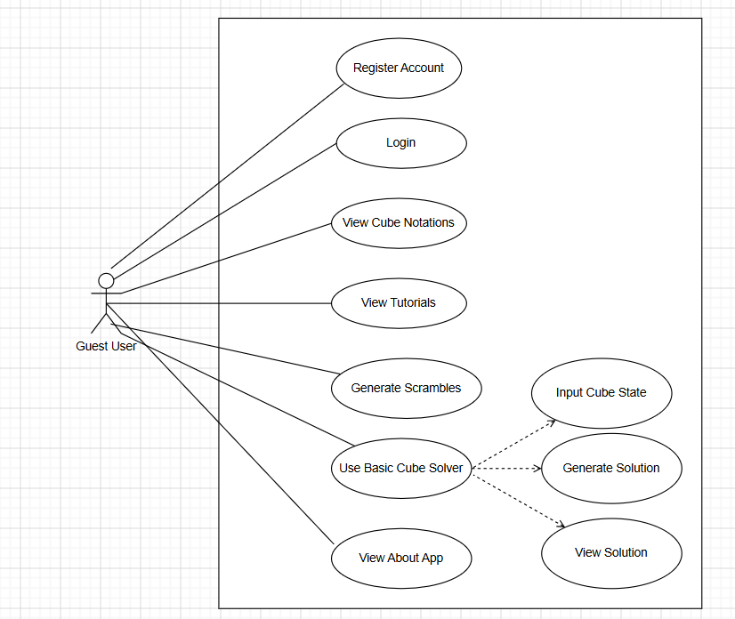

Description:
The Guest User can access basic features of the Cube Solver application without creating an account.
Precondition:
The application is installed and accessible to the user.
Postcondition:
The user can use available guest features or proceed to registration/login.
Trigger:
The user opens the application as a guest.
Main Success Scenario:
- User opens the application.
- User can view tutorials and cube notation.
- User can generate a scramble.
- User can use the basic cube solver.
- User can view information about the application.
- User can register or log in for additional features.
Exceptional Scenario:
- Application fails to load.
- Required content cannot be retrieved.
- Invalid cube state is entered.
USE CASE 2: Registered User

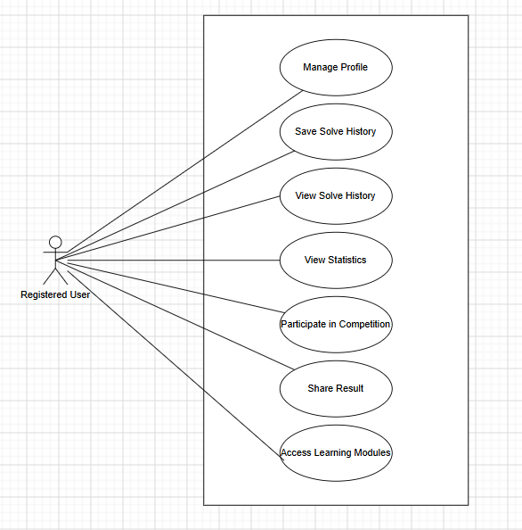

Description:
The Registered User can access personalized features such as profile management, solve history, statistics, challenges, and learning modules.
Precondition:
The user must have a valid account and be logged in.
Postcondition:
User information, solve records, and learning progress are stored successfully.
Trigger:
The user successfully logs into the application.
Main Success Scenario:
- User logs into the application.
- User manages their profile.
- User solves the cube and saves the solve history.
- User views solving statistics.
- User participates in challenges.
- User accesses learning modules.
- User can share solving results.
Exceptional Scenario:
- Invalid login credentials.
- Account is suspended.
- Server or database is unavailable.

USE CASE 3: Beginner User
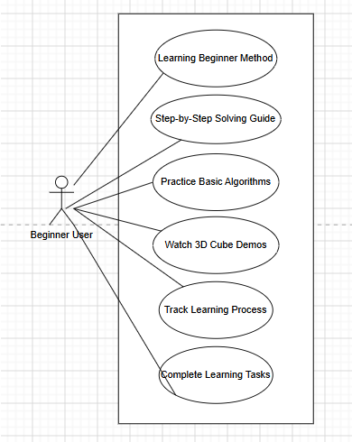
Description:
The Beginner User can learn basic Rubik’s Cube solving methods through guided lessons and 3D demonstrations.
Precondition:
The user is registered and has access to the beginner learning module.
Postcondition:
The user's learning progress and completed tasks are recorded.
Trigger:
The user selects the Beginner Learning Module.
Main Success Scenario:
- User opens the beginner module.
- User learns cube basics and notation.
- User follows the step-by-step solving guide.
- User practices basic algorithms.
- User watches 3D cube demonstrations.
- System records learning progress.
- User completes learning tasks.
Exceptional Scenario:
- Learning content cannot be loaded.
- 3D demonstration is unavailable.
- Learning progress cannot be saved.

USE CASE 4: Advanced User

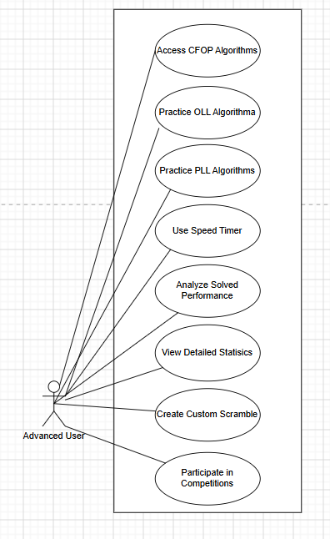

Description:
The Advanced User can practice advanced solving methods, analyze performance, and participate in competitive activities.
Precondition:
The user must be registered and have access to advanced features.
Postcondition:
Practice results and solving performance are recorded.
Trigger:
The user opens the Advanced Learning Module.
Main Success Scenario:
- User accesses CFOP algorithms.
- User practices OLL and PLL algorithms.
- User creates or applies custom scrambles.
- User uses the speed timer.
- User analyzes solving performance.
- User views detailed statistics.
- User participates in competitions.
Exceptional Scenario:
- Algorithm content is unavailable.
- Timer fails to record the result.
- Statistics cannot be generated.
- Network connection is unavailable for online competitions.
- Server or database is unavailable.
USE CASE 5: Admin User

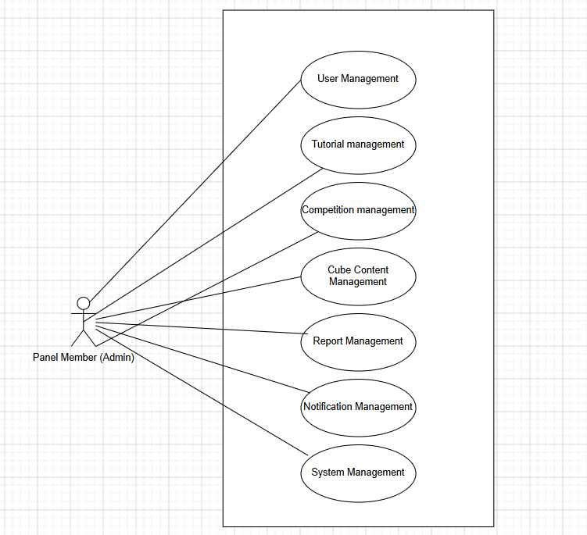

Description:
The Admin manages users, tutorials, challenges, cube content, reports, notifications, and system settings.
Precondition:
The user must have valid administrator credentials and appropriate privileges.
Postcondition:
The requested administrative information or content is successfully created, modified, deleted, or managed.
Trigger:
The Admin logs in and accesses the administration panel.
Main Success Scenario:
- Admin logs into the administration panel.
- Admin manages user accounts.
- Admin manages tutorials and learning content.
- Admin creates and manages challenges.
- Admin manages cube algorithms and guides.
- Admin views reports and statistics.
- Admin sends notifications and announcements.
- Admin manages system settings and backups.
Exceptional Scenario:
- Invalid administrator credentials.
- Unauthorized operation.
- Requested data does not exist.
- Database or server is unavailable.

2.4 Operating Environment
The application is designed for Android and iOS mobile devices with touchscreen support. The system uses React Native and Expo for mobile development, Three.js/React Three Fiber for 3D rendering, Node.js and Express.js for backend services, and PostgreSQL for data storage. Internet connectivity is required for server-based features.

2.5 Design and Implementation Constraints
• The application must support touchscreen-based interaction.
• The 3D cube must provide smooth and accurate rotations.
• The visual cube and internal cube state must remain synchronized.
• User data and passwords must be securely stored.
• The application should provide good performance on commonly used mobile devices.

2.6 User Documentation
The application will provide appropriate documentation and guidance to help users understand and operate the system.
The documentation may include:
- User registration and login instructions
- 3D cube interaction guide
- Cube notation guide
- Scramble and solving instructions
- Beginner solving tutorials
- CFOP, OLL, and PLL learning materials
- Speed timer instructions
- Challenge and leaderboard instructions
- Profile and statistics guide
- Frequently Asked Questions (FAQ)
- Troubleshooting information
An administrator or developer documentation will also describe system configuration, database setup, API usage, deployment, and maintenance procedures.

2.7 Assumptions and Dependencies

Assumptions
- Users have basic knowledge of using a touchscreen mobile application.
- Users provide valid information during registration and profile creation.
- Users have sufficient device resources to render the interactive 3D cube.
- Users have an active internet connection when accessing server-dependent features.
- The cube state entered by the user represents a standard 3×3 Rubik’s Cube.
- Administrators have the required authorization to manage system content and users.

Dependencies
The application depends on:
- React Native and Expo for mobile application development.
- Three.js / React Three Fiber for interactive 3D rendering.
- Node.js and Express.js for backend services.
- PostgreSQL for persistent data storage.
- Internet connectivity for communication between the mobile application and backend services.
3. External Interface Requirements
3.1 User Interfaces
The application shall provide a simple and user-friendly mobile interface for interacting with the Cube Solver system. The main interface will include a 3D Rubik’s Cube, navigation menus, solver controls, learning modules, timer, statistics, and user profile. Users shall be able to interact with the 3D cube using touch gestures to rotate the entire cube, individual faces, rows, and columns. The interface shall provide clear buttons for actions such as Scramble, Solve, Reset, Undo, Redo, Play, and Pause. The application shall maintain a consistent and responsive design across supported mobile screen sizes.
3.2 Hardware Interfaces
The application will operate on smartphones and tablets equipped with a touchscreen, processor, memory, display, and graphics processing capability. The touchscreen will be used for cube manipulation, navigation, and other user interactions. The device's GPU will be utilized for rendering the interactive 3D cube and its animations. Internet connectivity through Wi-Fi or mobile data may be required for online features.
3.3 Software Interfaces
The mobile application will use React Native with Expo as the primary development platform. Three.js/React Three Fiber will be used for interactive 3D cube rendering and animations.
The backend will use Node.js and Express.js to provide APIs and application services. PostgreSQL will be used for storing user accounts, solve history, tutorials, algorithms, challenges, and other application data.
The application will communicate with the backend through REST APIs.
3.4 Communications Interfaces
The application shall communicate with the backend server using the HTTP/HTTPS protocol. HTTPS will be used to provide secure communication between the mobile application and server. REST APIs will be used for operations such as user authentication, retrieving tutorials, storing solve history, managing challenges, and retrieving statistics. Internet connectivity through Wi-Fi or mobile data will be required for server-dependent features.

4. System Features
This section organizes the functional requirements of CIBS by feature area. Each featureincludes a short description, its relative priority, representative user/system interactionsequences, and the itemized requirements that a development team can implement and a test team can verify.
4.1 User Registration and Authentication

4.1.1 Description and Priority
This feature allows users to create an account and securely access the application. It supports registration, login, logout, and authentication.
Priority: High.
4.1.2 Stimulus/Response Sequences
Stimulus: User enters registration or login details.
Response: The system validates the details and creates an account or grants access. If the details are invalid, an appropriate error message is displayed.
4.1.3 Functional Requirements
• The system shall allow users to register using required personal details.
• The system shall authenticate registered users using valid credentials.
• The system shall provide logout functionality.
• The system shall securely store user credentials.
• The system shall display appropriate messages for invalid login or registration details.

4.2 Catalog Browsing and Search
4.2.1 Description and Priority
This feature provides an interactive 3D Rubik’s Cube that allows users to rotate the complete cube and individual layers using touch gestures.
Priority: High
4.2.2 Stimulus/Response Sequences
Stimulus: User drags or swipes on the 3D cube.
Response: The system identifies the selected face, row, or column and performs the corresponding 3D rotation with animation.

4.2.3 Functional Requirements
• The system shall display a 3×3×3 3D Rubik’s Cube.
• The system shall allow users to rotate the complete cube.
• The system shall allow face, row, and column rotations.
• The system shall provide smooth 90-degree rotation animations.
• The system shall maintain the correct logical cube state after every move.
• The system shall provide reset, undo, and redo operations.

4.3 Item Borrowing Request

4.3.1 Description and Priority
This feature allows users to generate a scramble or manually configure the cube before solving.
Priority: High
4.3.2 Stimulus/Response Sequences
Stimulus: User selects Scramble or enters a cube configuration manually.
Response: The system generates a valid scramble or updates the cube according to the selected configuration and validates it.
4.3.3 Functional Requirements
• The system shall generate valid Rubik’s Cube scrambles.
• The system shall display the generated scramble notation.
• The system shall allow users to apply a scramble to the 3D cube.
• The system shall allow manual cube configuration.
• The system shall validate the entered cube configuration.
• The system shall identify invalid or impossible cube states.

4.4 Request Approval Workflow
4.4.1 Description and Priority
This feature generates a valid sequence of moves to solve the user's current cube configuration.
Priority: High
4.4.2 Stimulus/Response Sequences
Stimulus: User selects Solve Cube after providing a valid cube state.
Response: The system processes the cube state, generates a solution, verifies it, and displays the required moves.

4.4.3 Functional Requirements
• The system shall accept a valid cube state.
• The system shall generate a valid solving sequence.
• The system shall display the solution using standard cube notation.
• The system shall verify that the generated solution solves the cube.
• The system shall display an error when a solution cannot be generated.
• The system shall allow users to view the solution step-by-step.

4.5 Item Return and Condition Tracking
4.5.1 Description and Priority
This feature visually demonstrates the generated solution and provides learning resources for beginner and advanced users.
Priority: High
4.5.2 Stimulus/Response Sequences
Stimulus: User selects Play Solution or opens a learning lesson.
Response: The system animates each cube move or displays the selected learning content.
4.5.3 Functional Requirements
- The system shall animate solution moves on the 3D cube.
- The system shall provide play, pause, next, previous, and reset controls.
- The system shall provide beginner solving lessons.
- The system shall provide advanced topics such as CFOP, OLL, and PLL.
- The system shall provide algorithm demonstrations and practice.
- The system shall track learning progress for registered users.
4.6 Automated Notifications and Reminders
4.6.1 Description and Priority
This feature enables users to record solving times and monitor their performance over multiple attempts.
Priority: Medium
4.6.2 Stimulus/Response Sequences
Stimulus: User starts and stops the timer while solving a scramble.
Response: The system records the solve time and stores the result in the user's history.
4.6.3 Functional Requirements
- The system shall send notifications for new challenges and challenge updates.
- The system shall provide reminders for scheduled learning or practice activities.
- The system shall notify users about important application updates.
- The system shall display notifications within the application.
- The system shall allow users to view and manage their notifications.
- The system shall allow users to enable or disable non-essential notifications.
- The system shall mark notifications as read after the user views them.

5. Other Nonfunctional Requirements
5.1 Performance Requirements
- The application shall provide smooth interaction with the 3D Rubik’s Cube.
- Cube rotations and animations should respond quickly to user gestures.
- The application should load screens and stored data within a reasonable response time.
- The system should support multiple users without significant performance degradation.
- The application should minimize memory and processing usage on mobile devices.
5.2 Safety Requirements
- The application shall prevent invalid cube operations that could cause inconsistent cube states.
- The system shall validate user-entered cube configurations before attempting to solve them.
- The application shall handle unexpected errors without crashing whenever possible.
- User data shall be protected from accidental loss through appropriate database and backup mechanisms.
- The application shall provide clear error messages without exposing technical information to users.
5.3 Security Requirements
- The system shall authenticate users before providing access to protected features.
- User passwords shall be securely hashed and shall not be stored as plain text.
- Role-based authorization shall restrict administrative functions to authorized users.
- Communication between the mobile application and backend shall use secure HTTPS connections.
- Sensitive information such as database credentials and secret keys shall be stored securely.
- The system shall validate user input to reduce security risks such as unauthorized database access.
5.4 Software Quality Attributes
- Usability: The interface shall be simple, clear, and easy to navigate.
- Reliability: The system shall provide consistent cube operations and accurate solutions.
- Performance: 3D interactions and animations shall remain responsive.
- Maintainability: The application shall use modular and well-structured code.
- Scalability: The system should support increasing users and application data.
- Portability: The application should support compatible Android and iOS devices.
- Availability: Server-dependent features should be available whenever the backend service is operational.

5.5 Business Rules
- Only registered users can save personal solve history and access personalized statistics.
- Only authorized administrators can manage users, tutorials, algorithms, and challenges.
- A cube must have a valid configuration before the solver can generate a solution.
- Challenge results shall be recorded only for valid completed attempts.
- Each user shall have access only to their own private profile and solve history.
- Beginner and advanced learning content shall be available according to the user's selected learning level.
- Administrative actions shall be restricted according to the assigned user role.

6. Other Requirements
6.1 Data Requirements
- The system shall maintain accurate user account information.
- The system shall store valid solve history for registered users.
- The system shall maintain cube configurations and solution records.
- The system shall store learning progress, challenge results, and statistics.
- The system shall prevent unauthorized access to private user data.
- The database shall maintain data consistency during create, update, and delete operations.
6.2 Database Requirements
- The system shall use a relational database for persistent data storage.
- The database shall maintain separate records for users, solve history, statistics, challenges, tutorials, and notifications.
- The system shall use unique identifiers for stored records.
- The system shall enforce appropriate relationships and constraints between database entities.
- Database access shall be performed through the backend server.
6.3 API Requirements
- The mobile application shall communicate with the backend using REST APIs.
- The API shall support authentication, cube solving, validation, statistics, tutorials, challenges, and user-related operations.
- The API shall return appropriate success and error responses.
- The backend shall validate requests before processing them.
- API communication shall use secure HTTPS in production.
6.4 Compatibility Requirements
- The application shall support compatible Android devices.
- The application should support compatible iOS devices.
- The application shall support touch-based interaction.
- The application shall operate correctly on supported screen sizes and resolutions.
- The application shall maintain consistent functionality across supported devices.
6.5 Backup and Recovery Requirements
- User data shall be backed up using appropriate database backup mechanisms.
- The system shall minimize permanent data loss caused by unexpected failures.
- The system shall recover gracefully from temporary backend or network failures.
- The application shall provide appropriate feedback when server-dependent operations cannot be completed.
6.6 Accessibility Requirements
- The application shall provide clear and readable text.
- Interactive controls shall be sufficiently visible and identifiable.
- Navigation shall be simple and consistent.
- Error messages shall be understandable to users.
- Important actions shall provide appropriate visual feedback.
6.7 Logging and Monitoring Requirements
- The backend shall record important application and server errors.
- Authentication and critical system operations shall be monitored.
- Database connection failures shall be logged for debugging.
- The system shall avoid exposing passwords, database credentials, or other sensitive information in logs.
6.8 Maintenance Requirements
- The application shall use modular components for easier maintenance.
- Frontend and backend modules shall be separated logically.
- Configuration values such as API URLs and database credentials shall be maintained separately from application logic.
- The source code shall follow consistent naming and documentation practices.
- The system shall allow future features to be added without major changes to existing modules.

Appendix B: Analysis Models
The analysis models represent the functional structure and behavior of the Cube Solver Mobile Application. They provide a visual representation of the system, its users, processes, and interactions.
UML CLASS DIAGRAM:

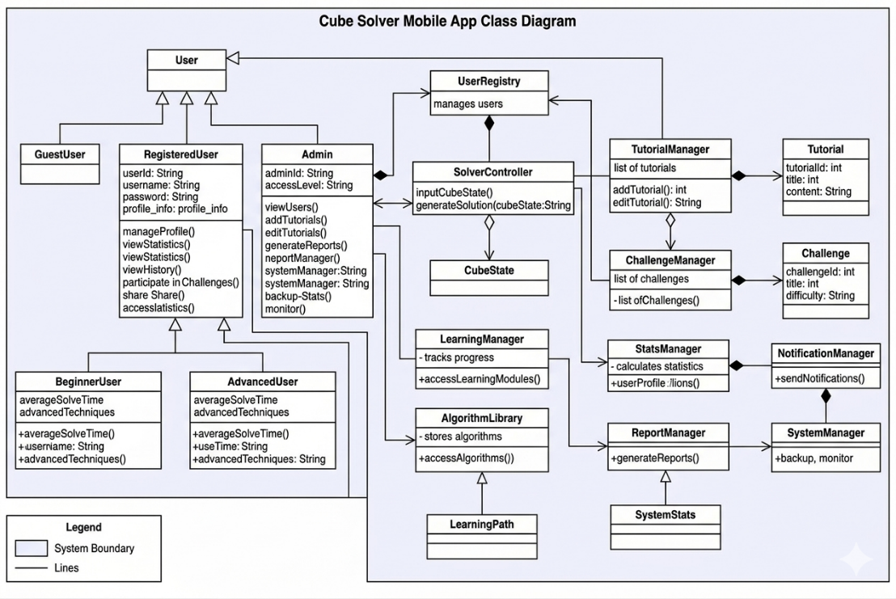

UML ACTIVITY DIAGRAM:

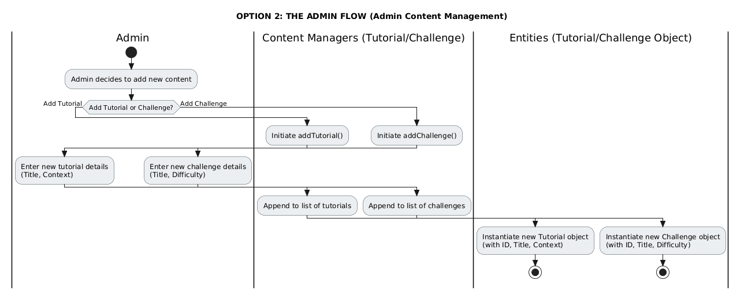

UML SEQUENCE DIAGRAM:

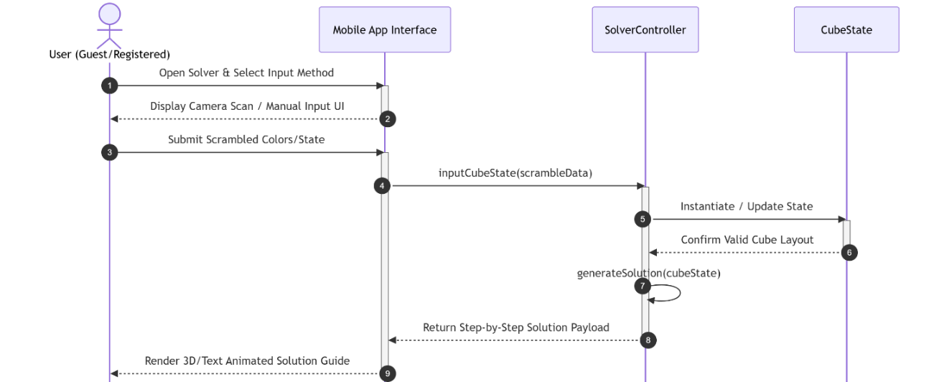

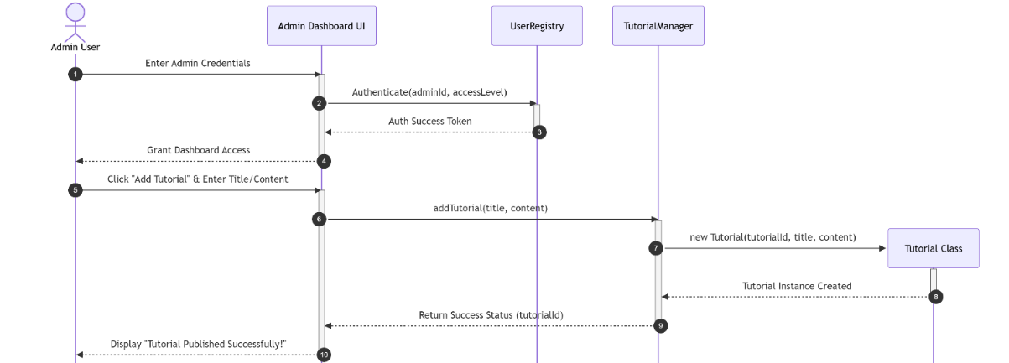

UML STATE CHART DIAGRAM:

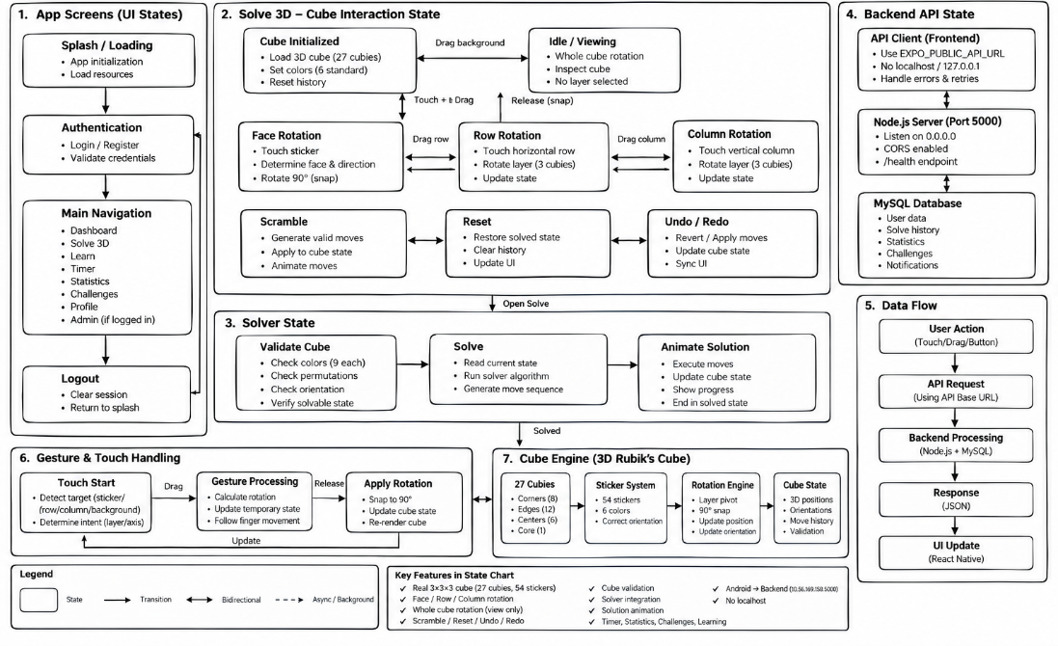
UML COMPONENT DIAGRAM:

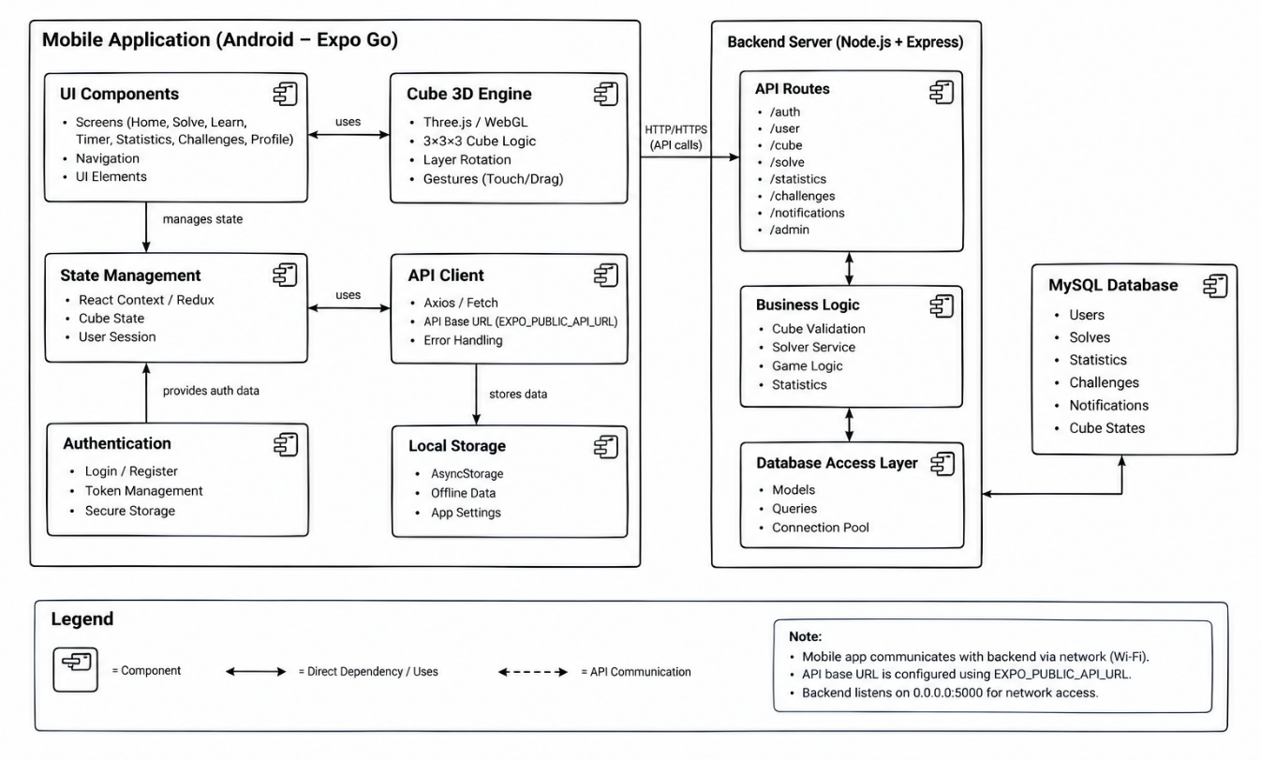

UML DEPLOYMENT DIAGRAM:

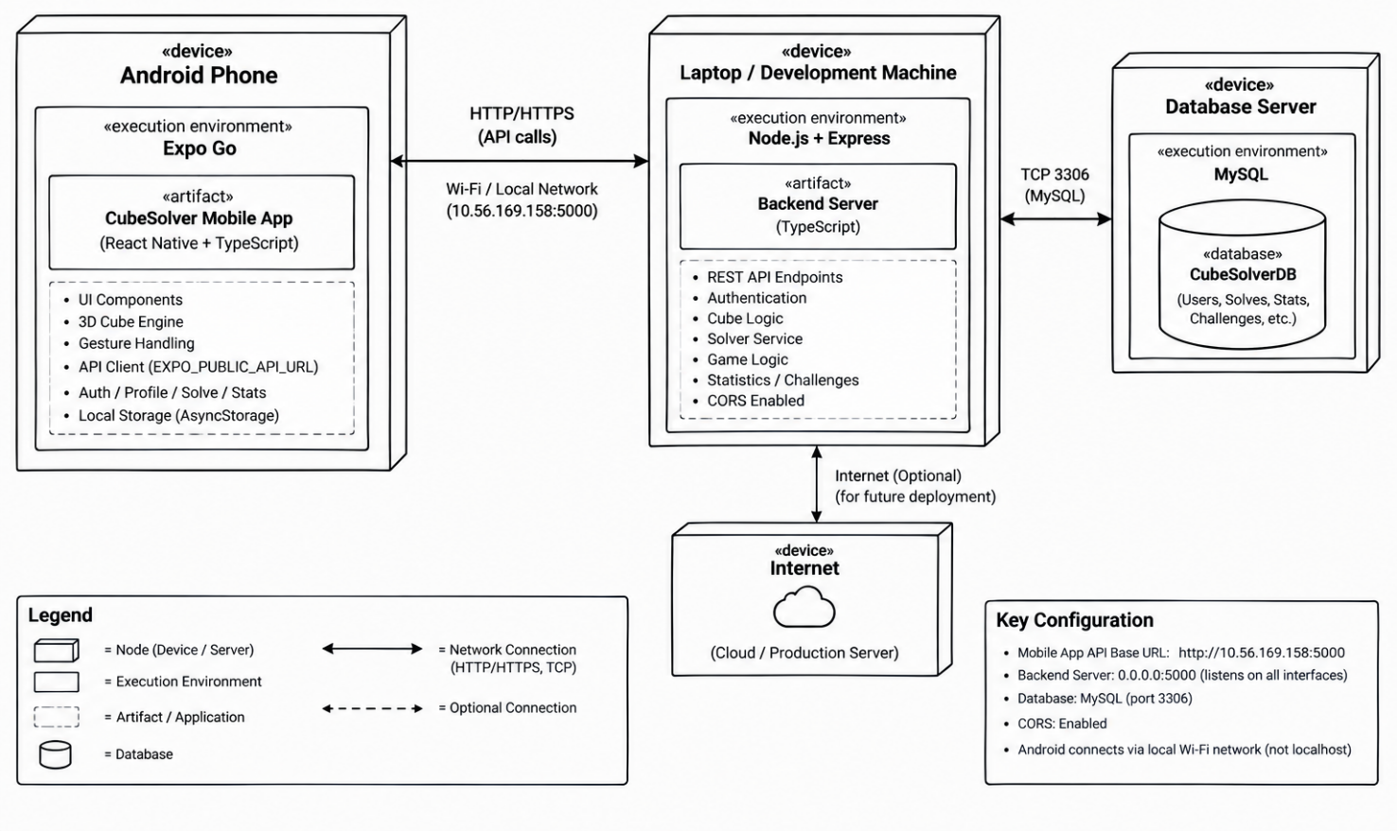
SOURCE CODE:
SE\frontend\src\api\client.ts

const rawUrl = process.env.EXPO_PUBLIC_API_URL || 'http://10.56.169.158:5000';
export const API_BASE_URL = rawUrl.replace(/\/+$/, '');

console.log(`[API Client] Initialized with Base URL: ${API_BASE_URL}`);

let authToken: string | null = null;

export function setAuthToken(token: string | null) {
authToken = token;
}

export function getAuthToken(): string | null {
return authToken;
}

async function request<T>(endpoint: string, options: RequestInit = {}): Promise<T> {
const headers: Record<string, string> = {
'Content-Type': 'application/json',
...(options.headers as Record<string, string>)
};

if (authToken) {
headers['Authorization'] = `Bearer ${authToken}`;
}

const url = `${API_BASE_URL}${endpoint}`;

try {
const controller = new AbortController();
const timeoutId = setTimeout(() => controller.abort(), 10000); // 10s timeout

const res = await fetch(url, {
...options,
headers,
signal: controller.signal
});

clearTimeout(timeoutId);

const json = await res.json();
if (!res.ok) {
throw new Error(json.message || `Server returned HTTP ${res.status}`);
}
return json;
} catch (error: any) {
const isNetworkError = error.name === 'AbortError' || error.message.includes('fetch failed') || error.message.includes('Network request failed') || error.message.includes('ConnectException');
const userMessage = isNetworkError
? `Cannot reach backend at ${API_BASE_URL}. Ensure your Android device and PC are on the same Wi-Fi and port 5000 is open.`
: error.message || 'API request failed';

console.error(`[API Error] ${endpoint}:`, userMessage);
throw new Error(userMessage);
}
}

export const api = {
// 1. Authentication APIs
auth: {
login: async (email: string, pass: string) => {
const res = await request<any>('/auth/login', {
method: 'POST',
body: JSON.stringify({ email, password: pass })
});
if (res.token) setAuthToken(res.token);
return res;
},

register: async (name: string, email: string, pass: string) => {
const res = await request<any>('/auth/register', {
method: 'POST',
body: JSON.stringify({ name, email, password: pass })
});
if (res.token) setAuthToken(res.token);
return res;
},

forgotPassword: async (email: string) => {
return request<any>('/auth/forgot-password', {
method: 'POST',
body: JSON.stringify({ email })
});
},

getProfile: async () => {
return request<any>('/user/profile');
}
},

// 2. 3D Cube & Solver Engine APIs
cube: {
solve: async (scrambleOrState: string | string[]) => {
const body = typeof scrambleOrState === 'string'
? { scramble: scrambleOrState }
: { cubeState: scrambleOrState };
return request<any>('/cube/solve', {
method: 'POST',
body: JSON.stringify(body)
});
},

validate: async (cubeState: any) => {
return request<any>('/cube/validate', {
method: 'POST',
body: JSON.stringify({ cubeState })
});
},

getScramble: async (length: number = 20) => {
return request<any>(`/cube/scramble?length=${length}`);
},

saveState: async (data: { title: string; cubeState: any; scramble?: string; isSolved?: boolean }) => {
return request<any>('/cube/save', {
method: 'POST',
body: JSON.stringify(data)
});
},

getSavedStates: async () => {
return request<any>('/cube/saved');
}
},

// 3. Solve History & Timer APIs
solve: {
save: async (data: {
scramble: string;
time_ms: number;
moves_count?: number;
solution_moves?: string;
cube_type?: string;
}) => {
return request<any>('/solve/save', {
method: 'POST',
body: JSON.stringify(data)
});
},

getHistory: async (limit: number = 50) => {
return request<any>(`/solve/history?limit=${limit}`);
},

delete: async (id: number | string) => {
return request<any>(`/solve/${id}`, {
method: 'DELETE'
});
}
},

// 4. Statistics APIs
stats: {
get: async () => {
return request<any>('/stats');
}
},

// 5. Challenges & Leaderboards APIs
challenges: {
getAll: async () => {
return request<any>('/challenges');
},

submit: async (challengeId: number, time_ms: number, moves_count: number = 0) => {
return request<any>(`/challenges/${challengeId}/submit`, {
method: 'POST',
body: JSON.stringify({ time_ms, moves_count })
});
},

getLeaderboard: async (challengeId: number) => {
return request<any>(`/challenges/${challengeId}/leaderboard`);
}
},

// 6. Tutorials & Learning Module APIs
tutorials: {
getAll: async (category?: string) => {
const query = category ? `?category=${category}` : '';
return request<any>(`/tutorials${query}`);
},

getBySlug: async (slug: string) => {
return request<any>(`/tutorials/${slug}`);
}
},

// 7. Notifications APIs
notifications: {
getAll: async () => {
return request<any>('/notifications');
},

markAsRead: async (id: string | number) => {
return request<any>(`/notifications/${id}/read`, {
method: 'PUT'
});
}
},

// 8. Admin Control Center APIs
admin: {
getReports: async () => {
return request<any>('/admin/reports');
},

getUsers: async () => {
return request<any>('/admin/users');
},

createTutorial: async (data: any) => {
return request<any>('/admin/tutorials', {
method: 'POST',
body: JSON.stringify(data)
});
},

createChallenge: async (data: any) => {
return request<any>('/admin/challenges', {
method: 'POST',
body: JSON.stringify(data)
});
}
}};

SE\frontend\src\components\ColorPickerModal.tsx
import React from 'react';
import { View, Text, StyleSheet, TouchableOpacity, Modal, ScrollView } from 'react-native';
import { Ionicons } from '@expo/vector-icons';
import { colors } from '../theme/colors';
import { useCube, CubeColor } from '../context/CubeContext';

interface ColorPickerModalProps {
visible: boolean;
onClose: () => void;
}

export const ColorPickerModal: React.FC<ColorPickerModalProps> = ({ visible, onClose }) => {
const {
selectedColor,
setSelectedColor,
setColorEditing,
faceletColors,
updateFaceletColor,
resetCube
} = useCube();

const palette: { name: CubeColor; hex: string; label: string }[] = [
{ name: 'white', hex: colors.cube.white, label: 'White' },
{ name: 'yellow', hex: colors.cube.yellow, label: 'Yellow' },
{ name: 'red', hex: colors.cube.red, label: 'Red' },
{ name: 'orange', hex: colors.cube.orange, label: 'Orange' },
{ name: 'blue', hex: colors.cube.blue, label: 'Blue' },
{ name: 'green', hex: colors.cube.green, label: 'Green' }
];

// Count stickers of each color
const counts: Record<string, number> = {
white: 0, yellow: 0, red: 0, orange: 0, blue: 0, green: 0
};
faceletColors.forEach(c => {
if (counts[c] !== undefined) counts[c]++;
});

const isBalanced = Object.values(counts).every(c => c === 9);

const handleSelectColor = (col: CubeColor) => {
setSelectedColor(col);
setColorEditing(true);
};

const handleFinish = () => {
setColorEditing(false);
onClose();
};

return (
<Modal visible={visible} transparent animationType="slide">
<View style={styles.overlay}>
<View style={styles.modalContent}>
{/* Header */}
<View style={styles.header}>
<View>
<Text style={styles.title}>Manual Color Editor</Text>
<Text style={styles.subtitle}>Tap a color below, then paint 3D or 2D stickers</Text>
</View>
<TouchableOpacity onPress={handleFinish} style={styles.closeBtn}>
<Ionicons name="checkmark" size={24} color={colors.accent} />
</TouchableOpacity>
</View>

{/* Color Palette Selector */}
<View style={styles.paletteRow}>
{palette.map((item) => {
const isSelected = selectedColor === item.name;
const count = counts[item.name] || 0;
return (
<TouchableOpacity
key={item.name}
style={[
styles.colorOption,
{ backgroundColor: item.hex },
isSelected && styles.colorOptionSelected
]}
onPress={() => handleSelectColor(item.name)}
activeOpacity={0.8}
>
{isSelected && (
<Ionicons
name="brush"
size={20}
color={item.name === 'white' || item.name === 'yellow' ? '#000' : '#fff'}
/>
)}
<View style={styles.countBadge}>
<Text style={styles.countText}>{count}/9</Text>
</View>
</TouchableOpacity>
);
})}
</View>

{/* Validation Status Indicator */}
<View style={[styles.statusBox, isBalanced ? styles.statusValid : styles.statusInvalid]}>
<Ionicons
name={isBalanced ? 'checkmark-circle' : 'alert-circle'}
size={18}
color={isBalanced ? colors.accent : colors.warning}
style={{ marginRight: 8 }}
/>
<Text style={styles.statusText}>
{isBalanced
? 'Valid cube: Exactly 9 stickers per color!'
: 'Cube is unbalanced: each of the 6 colors must have exactly 9 stickers.'}
</Text>
</View>

{/* Action Row */}
<View style={styles.actionRow}>
<TouchableOpacity style={styles.resetBtn} onPress={resetCube}>
<Ionicons name="refresh" size={16} color={colors.textSecondary} style={{ marginRight: 6 }} />
<Text style={styles.resetBtnText}>Reset to Solved</Text>
</TouchableOpacity>

<TouchableOpacity style={styles.doneBtn} onPress={handleFinish}>
<Text style={styles.doneBtnText}>Done Painting</Text>
</TouchableOpacity>
</View>
</View>
</View>
</Modal>
);
};

const styles = StyleSheet.create({
overlay: {
flex: 1,
backgroundColor: 'rgba(0, 0, 0, 0.75)',
justifyContent: 'flex-end'
},
modalContent: {
backgroundColor: '#121A2A',
borderTopLeftRadius: 28,
borderTopRightRadius: 28,
borderTopWidth: 1,
borderColor: 'rgba(255, 255, 255, 0.15)',
padding: 24,
paddingBottom: 36
},
header: {
flexDirection: 'row',
justifyContent: 'space-between',
alignItems: 'center',
marginBottom: 18
},
title: {
color: '#fff',
fontSize: 20,
fontWeight: '800'
},
subtitle: {
color: colors.textSecondary,
fontSize: 13,
marginTop: 2
},
closeBtn: {
padding: 8,
borderRadius: 16,
backgroundColor: 'rgba(16, 185, 129, 0.15)'
},
paletteRow: {
flexDirection: 'row',
justifyContent: 'space-between',
marginBottom: 20
},
colorOption: {
width: 48,
height: 48,
borderRadius: 16,
justifyContent: 'center',
alignItems: 'center',
borderWidth: 2,
borderColor: 'rgba(0, 0, 0, 0.4)',
position: 'relative'
},
colorOptionSelected: {
borderColor: '#fff',
transform: [{ scale: 1.15 }]
},
countBadge: {
position: 'absolute',
bottom: -18,
alignSelf: 'center'
},
countText: {
color: colors.textSecondary,
fontSize: 10,
fontWeight: '700'
},
statusBox: {
flexDirection: 'row',
alignItems: 'center',
padding: 12,
borderRadius: 14,
marginTop: 14,
marginBottom: 20
},
statusValid: {
backgroundColor: 'rgba(16, 185, 129, 0.15)',
borderColor: colors.accent,
borderWidth: 1
},
statusInvalid: {
backgroundColor: 'rgba(245, 158, 11, 0.15)',
borderColor: colors.warning,
borderWidth: 1
},
statusText: {
color: colors.text,
fontSize: 12,
flex: 1
},
actionRow: {
flexDirection: 'row',
gap: 12
},
resetBtn: {
flex: 1,
flexDirection: 'row',
alignItems: 'center',
justifyContent: 'center',
backgroundColor: 'rgba(255, 255, 255, 0.08)',
borderRadius: 14,
paddingVertical: 14
},
resetBtnText: {
color: colors.textSecondary,
fontSize: 14,
fontWeight: '600'
},
doneBtn: {
flex: 1.5,
backgroundColor: colors.primary,
borderRadius: 14,
alignItems: 'center',
justifyContent: 'center',
paddingVertical: 14
},
doneBtnText: {
color: '#fff',
fontSize: 15,
fontWeight: '800'
}
});

SE\frontend\src\components\CubeControls.tsx
import React, { useState } from 'react';
import { View, Text, TouchableOpacity, StyleSheet, ScrollView } from 'react-native';
import { Ionicons, MaterialCommunityIcons } from '@expo/vector-icons';
import { colors } from '../theme/colors';
import { useCube } from '../context/CubeContext';

interface CubeControlsProps {
onOpenColorPicker: () => void;
onOpenSaveModal: () => void;
}

export const CubeControls: React.FC<CubeControlsProps> = ({ onOpenColorPicker, onOpenSaveModal }) => {
const {
applyMove,
scrambleCube,
resetCube,
undoMove,
redoMove,
moveHistory,
undoneMoves,
solveCurrentCube,
isSolving,
isColorEditing
} = useCube();

const [showMovePad, setShowMovePad] = useState<boolean>(false);

const quickMoves = ['R', "R'", 'U', "U'", 'F', "F'", 'L', "L'", 'D', "D'", 'B', "B'"];

return (
<View style={styles.container}>
{/* Move History / Notation Bar */}
{moveHistory.length > 0 && (
<View style={styles.historyContainer}>
<Text style={styles.historyLabel}>MOVES ({moveHistory.length}):</Text>
<ScrollView horizontal showsHorizontalScrollIndicator={false} contentContainerStyle={styles.historyScroll}>
{moveHistory.slice(-10).map((move, idx) => (
<View key={idx} style={styles.historyBadge}>
<Text style={styles.historyText}>{move}</Text>
</View>
))}
</ScrollView>
</View>
)}

{/* Quick Move Buttons Drawer (Optional touch bar) */}
{showMovePad && (
<View style={styles.movePadContainer}>
<ScrollView horizontal showsHorizontalScrollIndicator={false} contentContainerStyle={styles.movePadScroll}>
{quickMoves.map((m) => (
<TouchableOpacity
key={m}
style={styles.moveButton}
onPress={() => applyMove(m)}
activeOpacity={0.7}
>
<Text style={styles.moveButtonText}>{m}</Text>
</TouchableOpacity>
))}
</ScrollView>
</View>
)}

{/* Primary Action Buttons Bar */}
<View style={styles.buttonBar}>
{/* Undo */}
<TouchableOpacity
style={[styles.actionBtn, moveHistory.length === 0 && styles.btnDisabled]}
onPress={undoMove}
disabled={moveHistory.length === 0}
>
<Ionicons name="arrow-undo" size={20} color={moveHistory.length > 0 ? colors.text : colors.textMuted} />
<Text style={[styles.btnText, moveHistory.length === 0 && styles.textDisabled]}>Undo</Text>
</TouchableOpacity>

{/* Redo */}
<TouchableOpacity
style={[styles.actionBtn, undoneMoves.length === 0 && styles.btnDisabled]}
onPress={redoMove}
disabled={undoneMoves.length === 0}
>
<Ionicons name="arrow-redo" size={20} color={undoneMoves.length > 0 ? colors.text : colors.textMuted} />
<Text style={[styles.btnText, undoneMoves.length === 0 && styles.textDisabled]}>Redo</Text>
</TouchableOpacity>

{/* Scramble */}
<TouchableOpacity style={[styles.actionBtn, styles.accentBtn]} onPress={() => scrambleCube()}>
<Ionicons name="shuffle" size={20} color="#fff" />
<Text style={styles.btnTextLight}>Scramble</Text>
</TouchableOpacity>

{/* Reset */}
<TouchableOpacity style={styles.actionBtn} onPress={resetCube}>
<Ionicons name="refresh" size={20} color={colors.text} />
<Text style={styles.btnText}>Reset</Text>
</TouchableOpacity>

{/* Color Edit Palette Mode */}
<TouchableOpacity
style={[styles.actionBtn, isColorEditing && styles.editActiveBtn]}
onPress={onOpenColorPicker}
>
<MaterialCommunityIcons
name="palette"
size={20}
color={isColorEditing ? colors.streakOrange : colors.text}
/>
<Text style={[styles.btnText, isColorEditing && { color: colors.streakOrange }]}>Paint</Text>
</TouchableOpacity>

{/* Toggle Moves Pad */}
<TouchableOpacity
style={[styles.actionBtn, showMovePad && styles.editActiveBtn]}
onPress={() => setShowMovePad(!showMovePad)}
>
<MaterialCommunityIcons name="keyboard-outline" size={20} color={showMovePad ? colors.primary : colors.text} />
<Text style={styles.btnText}>Pad</Text>
</TouchableOpacity>

{/* Save Cube */}
<TouchableOpacity style={styles.actionBtn} onPress={onOpenSaveModal}>
<Ionicons name="bookmark-outline" size={20} color={colors.text} />
<Text style={styles.btnText}>Save</Text>
</TouchableOpacity>
</View>

{/* Main Solve Solver Trigger Button */}
<View style={styles.solveButtonRow}>
<TouchableOpacity
style={[styles.solveButton, isSolving && styles.solvingActiveButton]}
onPress={() => solveCurrentCube()}
activeOpacity={0.85}
>
<Ionicons name="sparkles" size={22} color="#fff" style={{ marginRight: 8 }} />
<Text style={styles.solveButtonText}>
{isSolving ? 'SOLVER ACTIVE' : 'SOLVE CUBE'}
</Text>
</TouchableOpacity>
</View>
</View>
);
};

const styles = StyleSheet.create({
container: {
paddingHorizontal: 16,
paddingBottom: 16,
backgroundColor: 'transparent'
},
historyContainer: {
flexDirection: 'row',
alignItems: 'center',
marginBottom: 10,
backgroundColor: 'rgba(18, 26, 42, 0.65)',
borderRadius: 14,
paddingHorizontal: 12,
paddingVertical: 6,
borderWidth: 1,
borderColor: 'rgba(255, 255, 255, 0.08)'
},
historyLabel: {
color: colors.textMuted,
fontSize: 10,
fontWeight: '700',
marginRight: 8,
letterSpacing: 0.5
},
historyScroll: {
flexDirection: 'row',
alignItems: 'center',
gap: 6
},
historyBadge: {
backgroundColor: 'rgba(59, 130, 246, 0.2)',
borderRadius: 8,
paddingHorizontal: 8,
paddingVertical: 2,
borderWidth: 1,
borderColor: 'rgba(59, 130, 246, 0.4)'
},
historyText: {
color: '#93C5FD',
fontSize: 12,
fontWeight: '700'
},
movePadContainer: {
marginBottom: 10,
backgroundColor: 'rgba(30, 41, 59, 0.85)',
borderRadius: 16,
paddingVertical: 8,
paddingHorizontal: 8,
borderWidth: 1,
borderColor: colors.surfaceBorderActive
},
movePadScroll: {
flexDirection: 'row',
gap: 8,
paddingHorizontal: 4
},
moveButton: {
width: 44,
height: 44,
backgroundColor: colors.surface,
borderRadius: 12,
justifyContent: 'center',
alignItems: 'center',
borderWidth: 1,
borderColor: colors.surfaceBorder
},
moveButtonText: {
color: colors.text,
fontSize: 16,
fontWeight: '800'
},
buttonBar: {
flexDirection: 'row',
justifyContent: 'space-between',
gap: 6,
marginBottom: 12
},
actionBtn: {
flex: 1,
backgroundColor: 'rgba(30, 41, 59, 0.7)',
borderRadius: 14,
paddingVertical: 10,
alignItems: 'center',
justifyContent: 'center',
borderWidth: 1,
borderColor: colors.surfaceBorder
},
accentBtn: {
backgroundColor: 'rgba(59, 130, 246, 0.3)',
borderColor: colors.primary
},
editActiveBtn: {
borderColor: colors.streakOrange,
backgroundColor: 'rgba(255, 88, 0, 0.2)'
},
btnDisabled: {
opacity: 0.4
},
btnText: {
color: colors.text,
fontSize: 11,
fontWeight: '600',
marginTop: 3
},
btnTextLight: {
color: '#fff',
fontSize: 11,
fontWeight: '700',
marginTop: 3
},
textDisabled: {
color: colors.textMuted
},
solveButtonRow: {
width: '100%'
},
solveButton: {
backgroundColor: colors.primary,
flexDirection: 'row',
alignItems: 'center',
justifyContent: 'center',
borderRadius: 16,
paddingVertical: 14,
shadowColor: colors.primary,
shadowOffset: { width: 0, height: 4 },
shadowOpacity: 0.4,
shadowRadius: 12,
elevation: 8
},
solvingActiveButton: {
backgroundColor: colors.secondary
},
solveButtonText: {
color: '#fff',
fontSize: 16,
fontWeight: '800',
letterSpacing: 1
}
});

SE\frontend\src\components\GlassCard.tsx
import React from 'react';
import { View, StyleSheet, ViewStyle, StyleProp } from 'react-native';
import { colors, shadows } from '../theme/colors';

interface GlassCardProps {
children: React.ReactNode;
style?: StyleProp<ViewStyle>;
highlight?: boolean;
}

export const GlassCard: React.FC<GlassCardProps> = ({ children, style, highlight }) => {
return (
<View
style={[
styles.card,
highlight && styles.highlight,
shadows.glass,
style
]}
>
{children}
</View>
);
};

const styles = StyleSheet.create({
card: {
backgroundColor: colors.surfaceGlass,
borderRadius: 20,
borderWidth: 1,
borderColor: colors.surfaceBorder,
padding: 18,
overflow: 'hidden'
},
highlight: {
borderColor: colors.surfaceBorderActive,
backgroundColor: 'rgba(30, 41, 59, 0.85)'
}
});

SE\frontend\src\utils\cubeNotation.ts

export type Move =
| 'U' | "U'" | 'U2'
| 'D' | "D'" | 'D2'
| 'L' | "L'" | 'L2'
| 'R' | "R'" | 'R2'
| 'F' | "F'" | 'F2'
| 'B' | "B'" | 'B2'
| 'M' | "M'" | 'M2'
| 'E' | "E'" | 'E2'
| 'S' | "S'" | 'S2';

export const ALL_MOVES: Move[] = [
'U', "U'", 'U2',
'D', "D'", 'D2',
'L', "L'", 'L2',
'R', "R'", 'R2',
'F', "F'", 'F2',
'B', "B'", 'B2'
];

export const MOVE_DESCRIPTIONS: Record<string, string> = {
U: 'Turn Top face 90° clockwise',
"U'": 'Turn Top face 90° counter-clockwise',
U2: 'Turn Top face 180°',
D: 'Turn Bottom face 90° clockwise',
"D'": 'Turn Bottom face 90° counter-clockwise',
D2: 'Turn Bottom face 180°',
L: 'Turn Left face 90° clockwise',
"L'": 'Turn Left face 90° counter-clockwise',
L2: 'Turn Left face 180°',
R: 'Turn Right face 90° clockwise',
"R'": 'Turn Right face 90° counter-clockwise',
R2: 'Turn Right face 180°',
F: 'Turn Front face 90° clockwise',
"F'": 'Turn Front face 90° counter-clockwise',
F2: 'Turn Front face 180°',
B: 'Turn Back face 90° clockwise',
"B'": 'Turn Back face 90° counter-clockwise',
B2: 'Turn Back face 180°',
M: 'Turn Middle layer downwards',
"M'": 'Turn Middle layer upwards',
E: 'Turn Equator layer rightwards',
"E'": 'Turn Equator layer leftwards'
};

export function invertMove(move: string): string {
if (move.endsWith('2')) return move;
if (move.endsWith("'")) return move.slice(0, -1);
return `${move}'`;
}

export function invertMoves(moves: string[]): string[] {
return moves.slice().reverse().map(invertMove);
}

export function formatTime(ms: number): string {
if (ms === null || ms === undefined || isNaN(ms)) return '--:--';
const totalSeconds = ms / 1000;
const minutes = Math.floor(totalSeconds / 60);
const seconds = (totalSeconds % 60).toFixed(2);

if (minutes > 0) {
const formattedSec = Number(seconds) < 10 ? `0${seconds}` : seconds;
return `${minutes}:${formattedSec}`;
}
return `${seconds}s`;
}

export function generateWCAScramble(length: number = 20): string {
const faces = ['U', 'D', 'L', 'R', 'F', 'B'];
const modifiers = ['', "'", '2'];
const opposites: Record<string, string> = {
U: 'D', D: 'U',
L: 'R', R: 'L',
F: 'B', B: 'F'
};

const scramble: string[] = [];
let lastFace = '';
let secondLast = '';

for (let i = 0; i < length; i++) {
const choices = faces.filter(f => {
if (f === lastFace) return false;
if (f === secondLast && opposites[f] === lastFace) return false;
return true;
});

const chosen = choices[Math.floor(Math.random() * choices.length)];
const mod = modifiers[Math.floor(Math.random() * modifiers.length)];
scramble.push(`${chosen}${mod}`);

secondLast = lastFace;
lastFace = chosen;
}

return scramble.join(' ');
}

SE\database\schema.sql

CREATE DATABASE IF NOT EXISTS cube_solver_db CHARACTER SET utf8mb4 COLLATE utf8mb4_unicode_ci;
USE cube_solver_db;

-- ----------------------------------------------------------------------------
-- 1. USERS TABLE
-- ----------------------------------------------------------------------------
CREATE TABLE IF NOT EXISTS users (
id INT AUTO_INCREMENT PRIMARY KEY,
name VARCHAR(100) NOT NULL,
email VARCHAR(191) NOT NULL UNIQUE,
password_hash VARCHAR(255) NOT NULL,
role ENUM('user', 'admin') DEFAULT 'user',
avatar VARCHAR(255) DEFAULT 'https://images.unsplash.com/photo-1535713875002-d1d0cf377fde?auto=format&fit=crop&w=200&q=80',
preferred_theme VARCHAR(20) DEFAULT 'dark',
reset_token VARCHAR(255) NULL,
reset_token_expiry DATETIME NULL,
daily_streak INT DEFAULT 0,
last_active_date DATE NULL,
created_at TIMESTAMP DEFAULT CURRENT_TIMESTAMP,
updated_at TIMESTAMP DEFAULT CURRENT_TIMESTAMP ON UPDATE CURRENT_TIMESTAMP,
INDEX idx_user_email (email),
INDEX idx_user_role (role)
) ENGINE=InnoDB DEFAULT CHARSET=utf8mb4 COLLATE=utf8mb4_unicode_ci;

-- ----------------------------------------------------------------------------
-- 2. SOLVE HISTORY TABLE
-- ----------------------------------------------------------------------------
CREATE TABLE IF NOT EXISTS solve_history (
id INT AUTO_INCREMENT PRIMARY KEY,
user_id INT NOT NULL,
scramble VARCHAR(500) NOT NULL,
time_ms INT NOT NULL COMMENT 'Solve time in milliseconds',
moves_count INT DEFAULT 0,
solution_moves TEXT NULL,
cube_type VARCHAR(20) DEFAULT '3x3',
is_dnf TINYINT(1) DEFAULT 0 COMMENT 'Did Not Finish',
is_plus2 TINYINT(1) DEFAULT 0 COMMENT '+2 second penalty applied',
notes VARCHAR(255) NULL,
created_at TIMESTAMP DEFAULT CURRENT_TIMESTAMP,
FOREIGN KEY (user_id) REFERENCES users(id) ON DELETE CASCADE,
INDEX idx_solve_user_id (user_id),
INDEX idx_solve_time (time_ms),
INDEX idx_solve_created_at (created_at)
) ENGINE=InnoDB DEFAULT CHARSET=utf8mb4 COLLATE=utf8mb4_unicode_ci;

-- ----------------------------------------------------------------------------
-- 3. SAVED CUBE STATES TABLE
-- ----------------------------------------------------------------------------
CREATE TABLE IF NOT EXISTS saved_cubes (
id INT AUTO_INCREMENT PRIMARY KEY,
user_id INT NOT NULL,
title VARCHAR(100) NOT NULL,
cube_state JSON NOT NULL COMMENT 'JSON array or string of 54 facelet colors',
scramble VARCHAR(500) NULL,
is_solved TINYINT(1) DEFAULT 0,
created_at TIMESTAMP DEFAULT CURRENT_TIMESTAMP,
updated_at TIMESTAMP DEFAULT CURRENT_TIMESTAMP ON UPDATE CURRENT_TIMESTAMP,
FOREIGN KEY (user_id) REFERENCES users(id) ON DELETE CASCADE,
INDEX idx_saved_user_id (user_id)
) ENGINE=InnoDB DEFAULT CHARSET=utf8mb4 COLLATE=utf8mb4_unicode_ci;

-- ----------------------------------------------------------------------------
-- 4. TUTORIALS / LEARNING MODULE TABLE
-- ----------------------------------------------------------------------------
CREATE TABLE IF NOT EXISTS tutorials (
id INT AUTO_INCREMENT PRIMARY KEY,
category ENUM('beginner', 'cfop', 'f2l', 'oll', 'pll', 'speed_tricks') NOT NULL,
title VARCHAR(150) NOT NULL,
slug VARCHAR(150) NOT NULL UNIQUE,
description TEXT NOT NULL,
step_order INT DEFAULT 1,
algorithm VARCHAR(255) NULL,
illustration_url VARCHAR(255) NULL,
video_url VARCHAR(255) NULL,
content_markdown LONGTEXT NOT NULL,
difficulty ENUM('easy', 'intermediate', 'advanced') DEFAULT 'easy',
created_at TIMESTAMP DEFAULT CURRENT_TIMESTAMP,
updated_at TIMESTAMP DEFAULT CURRENT_TIMESTAMP ON UPDATE CURRENT_TIMESTAMP,
INDEX idx_tutorial_category (category),
INDEX idx_tutorial_order (step_order)
) ENGINE=InnoDB DEFAULT CHARSET=utf8mb4 COLLATE=utf8mb4_unicode_ci;

-- ----------------------------------------------------------------------------
-- 5. CHALLENGES TABLE
-- ----------------------------------------------------------------------------
CREATE TABLE IF NOT EXISTS challenges (
id INT AUTO_INCREMENT PRIMARY KEY,
title VARCHAR(150) NOT NULL,
description TEXT NOT NULL,
type ENUM('daily', 'weekly', 'special') NOT NULL,
scramble VARCHAR(500) NOT NULL,
target_time_ms INT NULL COMMENT 'Target benchmark time in ms',
points INT DEFAULT 100,
start_date DATE NOT NULL,
end_date DATE NOT NULL,
is_active TINYINT(1) DEFAULT 1,
created_at TIMESTAMP DEFAULT CURRENT_TIMESTAMP,
INDEX idx_challenge_active (is_active),
INDEX idx_challenge_dates (start_date, end_date)
) ENGINE=InnoDB DEFAULT CHARSET=utf8mb4 COLLATE=utf8mb4_unicode_ci;

-- ----------------------------------------------------------------------------
-- 6. USER CHALLENGE PARTICIPATION & LEADERBOARD
-- ----------------------------------------------------------------------------
CREATE TABLE IF NOT EXISTS user_challenges (
id INT AUTO_INCREMENT PRIMARY KEY,
challenge_id INT NOT NULL,
user_id INT NOT NULL,
time_ms INT NOT NULL,
moves_count INT DEFAULT 0,
solution_moves TEXT NULL,
points_earned INT DEFAULT 0,
completed_at TIMESTAMP DEFAULT CURRENT_TIMESTAMP,
FOREIGN KEY (challenge_id) REFERENCES challenges(id) ON DELETE CASCADE,
FOREIGN KEY (user_id) REFERENCES users(id) ON DELETE CASCADE,
UNIQUE KEY uq_user_challenge (challenge_id, user_id),
INDEX idx_user_challenge_time (time_ms)
) ENGINE=InnoDB DEFAULT CHARSET=utf8mb4 COLLATE=utf8mb4_unicode_ci;

-- ----------------------------------------------------------------------------
-- 7. NOTIFICATIONS TABLE
-- ----------------------------------------------------------------------------
CREATE TABLE IF NOT EXISTS notifications (
id INT AUTO_INCREMENT PRIMARY KEY,
user_id INT NOT NULL,
title VARCHAR(150) NOT NULL,
message TEXT NOT NULL,
type ENUM('reminder', 'challenge', 'achievement', 'system') DEFAULT 'system',
is_read TINYINT(1) DEFAULT 0,
created_at TIMESTAMP DEFAULT CURRENT_TIMESTAMP,
FOREIGN KEY (user_id) REFERENCES users(id) ON DELETE CASCADE,
INDEX idx_user_notifications (user_id, is_read)
) ENGINE=InnoDB DEFAULT CHARSET=utf8mb4 COLLATE=utf8mb4_unicode_ci;

-- ----------------------------------------------------------------------------
-- 8. SYSTEM STATS & AUDIT LOGS
-- ----------------------------------------------------------------------------
CREATE TABLE IF NOT EXISTS admin_audit_logs (
id INT AUTO_INCREMENT PRIMARY KEY,
admin_id INT NOT NULL,
action VARCHAR(100) NOT NULL,
details TEXT NULL,
ip_address VARCHAR(45) NULL,
created_at TIMESTAMP DEFAULT CURRENT_TIMESTAMP,
FOREIGN KEY (admin_id) REFERENCES users(id) ON DELETE CASCADE
) ENGINE=InnoDB DEFAULT CHARSET=utf8mb4 COLLATE=utf8mb4_unicode_ci;

-- ============================================================================
-- SEED DATA
-- Default Admin & Demo User, Tutorials, and Challenges
-- ============================================================================

-- Password for demo users is 'Password123!' (bcrypt hash below)
-- $2a$10$wTqKxM8G75kFpYd8d38j7eZkX16B3O0m7uXvO14Z3Pqv8Ocm4a3mG
INSERT INTO users (id, name, email, password_hash, role, daily_streak, last_active_date) VALUES
(1, 'Admin Speedcuber', 'admin@cubesolver.com', '$2a$10$3Q7uKuvSjGhAMvkLU1W7zusiB2rMmgZIpR2Bt.37JYBYGfpy5IE4y', 'admin', 15, CURDATE()),
(2, 'Alex Turner', 'alex@cubesolver.com', '$2a$10$3Q7uKuvSjGhAMvkLU1W7zusiB2rMmgZIpR2Bt.37JYBYGfpy5IE4y', 'user', 7, CURDATE())
ON DUPLICATE KEY UPDATE id=id;

-- Sample Solve History for user 2 (Alex)
INSERT INTO solve_history (user_id, scramble, time_ms, moves_count, solution_moves, cube_type, created_at) VALUES
(2, "R' U' F R2 U' B2 D' F2 U B2 R2 D2 F' L' D2 B' R B2 U' F'", 18450, 48, "D R' F R D2 U R U' R' U2 R U R' U F R U R' U' F' U2 R U2 R' U' R U' R'", '3x3', DATE_SUB(NOW(), INTERVAL 5 DAY)),
(2, "D2 F2 R2 B2 U2 L2 D F2 D' B2 U F R B' D' R2 B F2 U' L", 16210, 44, "F R U R' U' F' U R U R' U R U2 R' U2 R U R' U' R' F R2 U' R' U' R U R' F'", '3x3', DATE_SUB(NOW(), INTERVAL 4 DAY)),
(2, "U B2 D2 F2 L2 B2 U' L2 D B2 R2 B' L D2 R2 B2 D F' R' U2", 14820, 42, "R U R' U' R' F R2 U' R' U' R U R' F' U R U2 R' U' R U' R'", '3x3', DATE_SUB(NOW(), INTERVAL 3 DAY)),
(2, "F2 R2 U2 B2 D' F2 D' B2 L2 U2 F' D2 L B' F2 U' R F' D' R", 15940, 45, "F R U' R' U' R U R' F' R U R' U R U2 R'", '3x3', DATE_SUB(NOW(), INTERVAL 2 DAY)),
(2, "B2 U2 R2 D2 F2 L2 F2 U' B2 D' R2 F R2 B' L U B2 R' D' F2", 13250, 39, "R U R' U' R' F R F' U2 R U2 R' U' R U R' U' R U' R'", '3x3', DATE_SUB(NOW(), INTERVAL 1 DAY)),
(2, "L2 D2 B2 R2 D' F2 D B2 R2 U' L2 B' D' R' F D2 L2 U B' L2", 12480, 38, "U R U' R' U' F' U F R U R' U' R' F R F'", '3x3', NOW())
ON DUPLICATE KEY UPDATE id=id;

-- Sample Tutorials
INSERT INTO tutorials (category, title, slug, description, step_order, algorithm, difficulty, content_markdown) VALUES
('beginner', '1. Cube Anatomy & Standard Notation', 'cube-basics-notation', 'Learn the faces, centers, edges, corners, and international WCA notation (R, L, U, D, F, B).', 1, 'R U R'' U''', 'easy',
'# The Anatomy of the 3x3 Rubik''s Cube\n\nThe Rubik''s Cube consists of **6 faces**, each with a distinct color:\n- **White** is opposite **Yellow**\n- **Green** is opposite **Blue**\n- **Red** is opposite **Orange**\n\n### Piece Types:\n1. **Centers (6)**: Fixed in position and determine the color of each face.\n2. **Edges (12)**: Have 2 colors each.\n3. **Corners (8)**: Have 3 colors each.\n\n### International Notation:\n- **R** = Right face clockwise 90°\n- **R''** = Right face counter-clockwise 90°\n- **R2** = Right face 180°\n- Same logic applies to **L** (Left), **U** (Up), **D** (Down), **F** (Front), and **B** (Back).'),

('beginner', '2. The White Daisy & White Cross', 'white-cross', 'First foundational step: place 4 white edges around the yellow center, then align them to form the white cross.', 2, 'F2 U R2', 'easy',
'# Step 1: Solving the White Cross\n\n1. Find the 4 white edge pieces.\n2. Move them to surround the yellow center, creating a "Daisy".\n3. Look at the second color of each white edge piece.\n4. Rotate the top layer until the non-white sticker matches its center color.\n5. Turn that face 180° (F2, R2, etc.) to bring it down to the white center!'),

('beginner', '3. First Layer Corners', 'first-layer-corners', 'Insert all 4 white corner pieces into their correct spots to complete the entire first layer.', 3, 'R U R'' U''', 'easy',
'# Step 2: First Layer Corners\n\nUse the universal 4-move "Sexy Move":\n`R U R'' U''`\n\nPosition a corner with White directly above where it belongs, then repeat `R U R'' U''` until the white sticker points downwards and colors match!'),

('beginner', '4. Second Layer (F2L Beginner)', 'second-layer-edges', 'Insert the 4 middle layer edge pieces into place without disturbing the solved white layer.', 4, 'U R U'' R'' U'' F'' U F', 'intermediate',
'# Step 3: Solving the Middle Layer\n\nIdentify an edge on the top layer without yellow. Align it with its matching center.\n- To move edge to the Right: `U R U'' R'' U'' F'' U F`\n- To move edge to the Left: `U'' L'' U L U F U'' F''`'),

('cfop', 'CFOP: Cross Mastery', 'cfop-cross', 'Advanced cross techniques: solve cross on bottom directly in 8 moves or fewer.', 1, 'D R'' F R D2', 'intermediate',
'# Advanced Cross Solving\n\nSpeedcubers solve the cross directly on the bottom face (White on bottom).\n- Inspect the cube during the 15-second inspection.\n- Plan the complete cross solution before executing the first move.\n- Average optimal cross is 6-7 moves!'),

('f2l', 'Basic F2L: Corner & Edge Pairing', 'f2l-basics', 'First Two Layers (F2L) pairs corner and edge pieces in the top layer and inserts them together.', 1, 'U (R U'' R'') U'' (F'' U F)', 'intermediate',
'# First Two Layers (F2L)\n\nInstead of solving corners and then edges separately, F2L pairs them up in the top layer and slots them into their correct position in a single sequence.'),

('oll', 'OLL 21: Cross Case (H shape)', 'oll-21-h', 'Orient all last layer yellow stickers to face up.', 1, 'R U2 R'' U'' R U R'' U'' R U'' R''', 'advanced',
'# OLL 21 (H Case)\n\nAll 4 yellow corners are pointing outwards. Execute:\n`R U2 R'' U'' R U R'' U'' R U'' R''`'),

('pll', 'PLL: T-Permutation', 'pll-t-perm', 'Swap adjacent corners and adjacent edges to finish the cube.', 1, 'R U R'' U'' R'' F R2 U'' R'' U'' R U R'' F''', 'advanced',
'# The Classic T-Perm\n\nSwaps two corners on the right and two opposite edges.\n`R U R'' U'' R'' F R2 U'' R'' U'' R U R'' F''`')
ON DUPLICATE KEY UPDATE id=id;

-- Sample Challenges
INSERT INTO challenges (id, title, description, type, scramble, target_time_ms, points, start_date, end_date, is_active) VALUES
(1, 'Daily Speed Sprint', 'Solve this standardized scramble as quickly as possible. Best time wins 150 XP!', 'daily', "R U' R2 U' B2 D' F2 U B2 R2 D2 F' L' D2 B' R B2 U' F' L2", 20000, 150, CURDATE(), DATE_ADD(CURDATE(), INTERVAL 1 DAY), 1),
(2, 'Weekly Sub-15 Mastery', 'Test your CFOP skills on this high-flow scramble. Target: Under 15.00 seconds!', 'weekly', "F2 R2 U2 B2 D' F2 D' B2 L2 U2 F' D2 L B' F2 U' R F' D' R2 B", 15000, 500, CURDATE(), DATE_ADD(CURDATE(), INTERVAL 7 DAY), 1)
ON DUPLICATE KEY UPDATE id=id;

-- User challenge entry for leaderboard
INSERT INTO user_challenges (challenge_id, user_id, time_ms, moves_count, solution_moves, points_earned) VALUES
(1, 2, 13850, 41, "D R' F R D2 U R U' R' U2 R U R' U F R U R' U' F' U2 R U2 R' U' R U' R'", 150)
ON DUPLICATE KEY UPDATE id=id;

-- Sample Notifications
INSERT INTO notifications (user_id, title, message, type, is_read) VALUES
(2, 'Daily Streak Active! 🔥', 'You are on a 7-day streak! Complete a solve today to keep your streak going.', 'reminder', 0),
(2, 'New Daily Challenge Available', 'Today''s sprint is live: can you beat the 20.00 second target?', 'challenge', 0),
(2, 'Achievement Unlocked 🏆', 'Sub-15 Silver: You achieved a solve time under 15 seconds!', 'achievement', 1);

SE\frontend\.expo\dev\logs\start.log
{"_e":"root:init","_t":1790779668841,"format":"v0-jsonl","version":"57.0.27"}
{"_e":"env:mode","_t":1790779668844,"nodeEnv":"development","babelEnv":"development","mode":"development"}
{"_e":"env:load","_t":1790779668855,"mode":"development","files":["../..\\..\\.env"],"env":{"EXPO_PUBLIC_API_URL":"http://10.56.169.158:5000"}}
{"_e":"devserver:start","_t":1790779669405,"mode":"development","web":true,"baseUrl":"","asyncRoutes":false,"routerRoot":"../..\\..\\app","serverComponents":false,"serverActions":false,"serverRendering":false,"apiRoutes":false,"exporting":false}
{"_e":"metro:config","_t":1790779670231,"serverRoot":"../..\\..","projectRoot":"../..\\..","exporting":false,"flags":{"autolinkingModuleResolution":false,"serverActions":false,"serverComponents":false,"reactCompiler":false,"optimizeGraph":false,"treeshaking":false,"logbox":false}}
{"_e":"expo:dev-tools-plugin:load","_t":1790779670744,"plugins":[]}
{"_e":"metro:instantiate","_t":1790779676930,"atlas":false,"workers":8,"host":"::","port":8081}

SE\backend\package-lock.json
{
"name": "cube-solver-backend",
"version": "1.0.0",
"lockfileVersion": 3,
"requires": true,
"packages": {
"": {
"name": "cube-solver-backend",
"version": "1.0.0",
"license": "MIT",
"dependencies": {
"bcryptjs": "^2.4.3",
"cors": "^2.8.5",
"dotenv": "^16.4.5",
"express": "^4.19.2",
"jsonwebtoken": "^9.0.2",
"mysql2": "^3.11.0"
},
"devDependencies": {
"@types/bcryptjs": "^2.4.6",
"@types/cors": "^2.8.17",
"@types/express": "^4.17.21",
"@types/jsonwebtoken": "^9.0.6",
"@types/node": "^22.5.0",
"tsx": "^4.19.0",
"typescript": "^5.5.4"
}
},
"node_modules/@esbuild/aix-ppc64": {
"version": "0.28.2",
"resolved": "https://registry.npmjs.org/@esbuild/aix-ppc64/-/aix-ppc64-0.28.2.tgz",
"integrity": "sha512-
2.1.34",
"negotiator": "0.6.3"
},
"engines": {
"node": ">= 0.6"
}
},
"node_modules/array-flatten": {
"version": "1.1.1",
"resolved": "https://registry.npmjs.org/array-flatten/-/array-flatten-1.1.1.tgz",
"integrity": "sha512-PCVAQswWemu6UdxsDFFX/+gVeYqKAod3D3UVm91jHwynguOwAvYPhx8nNlM++NqRcK6CxxpUafjmhIdKiHibqg==",
"license": "MIT"
},
"node_modules/aws-ssl-profiles": {
"version": "1.1.2",
"resolved": "https://registry.npmjs.org/aws-ssl-profiles/-/aws-ssl-profiles-1.1.2.tgz",
"integrity": "sha512-NZKeq9AfyQvEeNlN0zSYAaWrmBffJh3IELMZfRpJVWgrpEbtEpnjvzqBPf+mxoI287JohRDoa+/nsfqqiZmF6g==",
"license": "MIT",
"engines": {
"node": ">= 6.0.0"
}
},
"node_modules/bcryptjs": {
"version": "2.4.3",
"resolved": "https://registry.npmjs.org/bcryptjs/-/bcryptjs-2.4.3.tgz",
"integrity": "sha512-V/Hy/X9Vt7f3BbPJEi8BdVFMByHi+jNXrYkW3huaybV/kQ0KJg0Y6PkEMbn+zeT+i+SiKZ/HMqJGIIt4LZDqNQ==",
"license": "MIT"
},
"node_modules/body-parser": {
"version": "1.20.8",
"resolved": "https://registry.npmjs.org/body-parser/-/body-parser-1.20.8.tgz",
"integrity": "sha512-JNcyFQ64OiijEkPzUBTCe+hyPXUD/3LEldGQ6iF5LR1w00mx9o7xtDWHXBY2iItjdCFGoilOLNQbH943ut7pHA==",
"license": "MIT",
"dependencies": {
"bytes": "~3.1.2",
"content-type": "~1.0.5",
"debug": "2.6.9",
"depd": "2.0.0",
"destroy": "~1.2.0",
"http-errors": "~2.0.1",
"
"engines": {
"node": ">= 0.6"
}
},
"node_modules/express": {
"version": "4.22.3",
"resolved": "https://registry.npmjs.org/express/-/express-4.22.3.tgz",
"integrity": "sha512-Bdcs4+3qlpVlx2NRn6fgX2Ue2/gGRaPeawebgclM0ERSCqDpA+owF1fdPwjJUTAJWMTuAaxjDf+hzb0/4eKvvw==",
"license": "MIT",
"dependencies": {
"accepts": "~1.3.8",
"array-flatten": "1.1.1",
"body-parser": "~1.20.5",
"content-disposition": "~0.5.4",
"content-type": "~1.0.4",
"cookie": "~0.7.1",
"cookie-signature": "~1.0.6",
"debug": "2.6.9",
"depd": "2.0.0",
"encodeurl": "~2.0.0",
"escape-html": "~1.0.3",
"etag": "~1.8.1",
"finalhandler": "~1.3.1",
"fresh": "~0.5.2",
"http-errors": "~2.0.0",
"merge-descriptors": "1.0.3",
"methods": "~1.1.2",
"on-finished": "~2.4.1",
"parseurl": "~1.3.3",
"path-to-regexp": "~0.1.13",
"proxy-addr": "~2.0.7",
"qs": "~6.16.0",
"range-parser": "~1.2.1",
"safe-buffer": "5.2.1",
"send": "~0.19.0",
"serve-static": "~1.16.2",
"setprototypeof": "1.2.0",
"statuses": "~2.0.1",
"type-is": "~1.6.18",
"utils-merge": "1.0.1",
"vary": "~1.1.2"
},
"engines": {
"node": ">= 0.10.0"
},
"funding": {
"type": "opencollective",
"url": "https://opencollective.com/express"
}
},
"node_modules/finalhandler": {
"version": "1.3.2",
"resolved": "https://registry.npmjs.org/finalhandler/-/finalhandler-1.3.2.tgz",
"integrity": "sha512-aA4RyPcd3badbdABGDuTXCMTtOneUCAYH/gxoYRTZlIJdF0YPWuGqiAsIrhNnnqdXGswYk6dGujem4w80UJFhg==",
"license": "MIT",
"dependencies": {
"debug": "2.6.9",
"encodeurl": "~2.0.0",
"escape-html": "~1.0.3",
"on-finished": "~2.4.1",
"parseurl": "~1.3.3",
"statuses": "~2.0.2",
"unpipe": "~1.0.0"
},
"engines": {
"node": ">= 0.8"
}
},
"node_modules/forwarded": {
"version": "0.2.0",
"resolved": "https://registry.npmjs.org/forwarded/-/forwarded-0.2.0.tgz",
"integrity": "sha512-buRG0fpBtRHSTCOASe6hD258tEubFoRLb4ZNA6NxMVHNw2gOcwHo9wyablzMzOA5z9xA9L1KNjk/Nt6MT9aYow==",
"license": "MIT",
"engines": {
"node": ">= 0.6"
}
},
"node_modules/lodash.includes": {
"version": "4.3.0",
"resolved": "https://registry.npmjs.org/lodash.includes/-/lodash.includes-4.3.0.tgz",
"integrity": "sha512-W3Bx6mdkRTGtlJISOvVD/lbqjTlPPUDTMnlXZFnVwi9NKJ6tiAk6LVdlhZMm17VZisqhKcgzpO5Wz91PCt5b0w==",
"license": "MIT"
},
"node_modules/lodash.isboolean": {
"version": "3.0.3",
"resolved": "https://registry.npmjs.org/lodash.isboolean/-/lodash.isboolean-3.0.3.tgz",
"integrity": "sha512-Bz5mupy2SVbPHURB98VAcw+aHh4vRV5IPNhILUCsOzRmsTmSQ17jIuqopAentWoehktxGd9e/hbIXq980/1QJg==",
"license": "MIT"
},
"node_modules/lodash.isinteger": {
"version": "4.0.4",
"resolved": "https://registry.npmjs.org/lodash.isinteger/-/lodash.isinteger-4.0.4.tgz",
"integrity": "sha512-DBwtEWN2caHQ9/imiNeEA5ys1JoRtRfY3d7V9wkqtbycnAmTvRRmbHKDV4a0EYc678/dia0jrte4tjYwVBaZUA==",
"license": "MIT"
},
"node_modules/lodash.isnumber": {
"version": "3.0.3",
"resolved": "https://registry.npmjs.org/lodash.isnumber/-/lodash.isnumber-3.0.3.tgz",
"integrity": "sha512-QYqzpfwO3/CWf3XP+Z+tkQsfaLL/EnUlXWVkIk5FUPc4sBdTehEqZONuyRt2P67PXAk+NXmTBcc97zw9t1FQrw==",
"license": "MIT"
},
"node_modules/lodash.isplainobject": {
"version": "4.0.6",
"resolved": "https://registry.npmjs.org/lodash.isplainobject/-/lodash.isplainobject-4.0.6.tgz",
"integrity": "sha512-oSXzaWypCMHkPC3NvBEaPHf0KsA5mvPrOPgQWDsbg8n7orZ290M0BmC/jgRZ4vcJ6DTAhjrsSYgdsW/F+MFOBA==",
"license": "MIT"
},
"node_modules/lodash.isstring": {
"version": "4.0.1",
"resolved": "https://registry.npmjs.org/lodash.isstring/-/lodash.isstring-4.0.1.tgz",
"integrity": "sha512-0wJxfxH1wgO3GrbuP+dTTk7op+6L41QCXbGINEmD+ny/G/eCqGzxyCsh7159S+mgDDcoarnBw6PC1PS5+wUGgw==",
"license": "MIT"
},
"node_modules/lodash.once": {
"version": "4.1.1",
"resolved": "https://registry.npmjs.org/lodash.once/-/lodash.once-4.1.1.tgz",
"integrity": "sha512-Sb487aTOCr9drQVL8pIxOzVhafOjZN9UU54hiN8PU3uAiSV7lx1yYNpbNmex2PK6dSJoNTSJUUswT651yww3Mg==",
"license": "MIT"
},
"node_modules/long": {
"version": "5.3.2",
"resolved": "https://registry.npmjs.org/long/-/long-5.3.2.tgz",
"integrity": "sha512-mNAgZ1GmyNhD7AuqnTG3/VQ26o760+ZYBPKjPvugO8+nLbYfX6TVpJPseBvopbdY+qpZ/lKUnmEc1LeZYS3QAA==",
"license": "Apache-2.0"
},
"node_modules/lru.min": {
"version": "1.1.5",
"resolved": "https://registry.npmjs.org/lru.min/-/lru.min-1.1.5.tgz",
"integrity": "sha512-5J9ysMYUpYIg9RF2vJpy9SinEmSviFSe0GyPpCQ4L5QSkLAgeLXlTAOu2ZwWUU5m+0SBl6gUU1R1ZQB3aKypfA==",
"license": "MIT",
"engines": {
"bun": ">=1.0.0",
"deno": ">=1.30.0",
"node": ">=8.0.0"
},
"funding": {
"type": "github",
"url": "https://github.com/sponsors/wellwelwel"
}
},
"node_modules/math-intrinsics": {
"version": "1.1.0",
"resolved": "https://registry.npmjs.org/math-intrinsics/-/math-intrinsics-1.1.0.tgz",
"integrity": "sha512-/IXtbwEk5HTPyEwyKX6hGkYXxM9nbj64B+ilVJnC/R6B0pH5G4V3b0pVbL7DBj4tkhBAppbQUlf6F6Xl9LHu1g==",
"license": "MIT",
"engines": {
"node": ">= 0.4"
}
},
"node_modules/media-typer": {
"version": "0.3.0",
"resolved": "https://registry.npmjs.org/media-typer/-/media-typer-0.3.0.tgz",
"integrity": "sha512-dq+qelQ9akHpcOl/gUVRTxVIOkAJ1wR3QAvb4RsVjS8oVoFjDGTc679wJYmUmknUF5HwMLOgb5O+a3KxfWapPQ==",
"license": "MIT",
"engines": {
"node": ">= 0.6"
}
},
"node_modules/merge-descriptors": {
"version": "1.0.3",
"resolved": "https://registry.npmjs.org/merge-descriptors/-/merge-descriptors-1.0.3.tgz",
"integrity": "sha512-gaNvAS7TZ897/rVaZ0nMtAyxNyi/pdbjbAwUpFQpN70GqnVfOiXpeUUMKRBmzXaSQ8DdTX4/0ms62r2K+hE6mQ==",
"license": "MIT",
"funding": {
"url": "https://github.com/sponsors/sindresorhus"
}
},
"node_modules/methods": {
"version": "1.1.2",
"resolved": "https://registry.npmjs.org/methods/-/methods-1.1.2.tgz",
"integrity": "sha512-iclAHeNqNm68zFtnZ0e+1L2yUIdvzNoauKU4WBA3VvH/vPFieF7qfRlwUZU+DA9P9bPXIS90ulxoUoCH23sV2w==",
"license": "MIT",
"engines": {
"node": ">= 0.6"
}
},
"node_modules/mime": {
"version": "1.6.0",
"resolved": "https://registry.npmjs.org/mime/-/mime-1.6.0.tgz",
"integrity": "sha512-x0Vn8spI+wuJ1O6S7gnbaQg8Pxh4NNHb7KSINmEWKiPE4RKOplvijn+NkmYmmRgP68mc70j2EbeTFRsrswaQeg==",
"license": "MIT",
"bin": {
"mime": "cli.js"
},
"engines": {
"node": ">=4"
}
},
"node_modules/mime-db": {
"version": "1.52.0",
"resolved": "https://registry.npmjs.org/mime-db/-/mime-db-1.52.0.tgz",
"integrity": "sha512-sPU4uV7dYlvtWJxwwxHD0PuihVNiE7TyAbQ5SWxDCB9mUYvOgroQOwYQQOKPJ8CIbE+1ETVlOoK1UC2nU3gYvg==",
"license": "MIT",
"engines": {
"node": ">= 0.6"
}
},
"node_modules/mime-types": {
"version": "2.1.35",
"resolved": "https://registry.npmjs.org/mime-types/-/mime-types-2.1.35.tgz",
"integrity": "sha512-ZDY+bPm5zTTF+YpCrAU9nK0UgICYPT0QtT1NZWFv4s++TNkcgVaT0g6+4R2uI4MjQjzysHB1zxuWL50hzaeXiw==",
"license": "MIT",
"dependencies": {
"mime-db": "1.52.0"
},
"engines": {
"node": ">= 0.6"
}
},
"node_modules/ms": {
"version": "2.0.0",
"resolved": "https://registry.npmjs.org/ms/-/ms-2.0.0.tgz",
"integrity": "sha512-Tpp60P6IUJDTuOq/5Z8cdskzJujfwqfOTkrwIwj7IRISpnkJnT6SyJ4PCPnGMoFjC9ddhal5KVIYtAt97ix05A==",
"license": "MIT"
},
"node_modules/mysql2": {
"version": "3.24.5",
"resolved": "https://registry.npmjs.org/mysql2/-/mysql2-3.24.5.tgz",
"integrity": "sha512-X6Ujsr2QSkkLpkQGjxzpKRAPn9nu4axpR63ntBzquFVEvPOArgbUQ1sJjFKI7hnaYtiVZxa17Z7q18KSubW0IQ==",
"license": "MIT",
"dependencies": {
"aws-ssl-profiles": "^1.1.2",
"generate-function": "^2.3.1",
"iconv-lite": "^0.7.3",
"long": "^5.3.2",
"lru.min": "^1.1.4",
"named-placeholders": "^1.1.6",
"sql-escaper": "^1.5.1"
},
"engines": {
"node": ">= 8.0"
},
"peerDependencies": {
"@types/node": ">= 8"
}
},
"node_modules/mysql2/node_modules/iconv-lite": {
"version": "0.7.3",
"resolved": "https://registry.npmjs.org/iconv-lite/-/iconv-lite-0.7.3.tgz",
"integrity": "sha512-IKXpvIzjnC9XTAUbVBcMfGS0EPaIXtW6v+zr+RRp+hqULEpo0owZax6wyRwPOJbWbzjYspQwusTsfVr0ifh4uQ==",
"license": "MIT",
"dependencies": {
"safer-buffer": ">= 2.1.2 < 3.0.0"
},
"engines": {
"node": ">=0.10.0"
},
"funding": {
"type": "opencollective",
"url": "https://opencollective.com/express"
}
},
"node_modules/named-placeholders": {
"version": "1.1.6",
"resolved": "https://registry.npmjs.org/named-placeholders/-/named-placeholders-1.1.6.tgz",
"integrity": "sha512-Tz09sEL2EEuv5fFowm419c1+a/jSMiBjI9gHxVLrVdbUkkNUUfjsVYs9pVZu5oCon/kmRh9TfLEObFtkVxmY0w==",
"license": "MIT",
"dependencies": {
"lru.min": "^1.1.0"
},
"engines": {
"node": ">=8.0.0"
}
},
"node_modules/negotiator": {
"version": "0.6.3",
"resolved": "https://registry.npmjs.org/negotiator/-/negotiator-0.6.3.tgz",
"integrity": "sha512-+EUsqGPLsM+j/zdChZjsnX51g4XrHFOIXwfnCVPGlQk/k5giakcKsuxCObBRu6DSm9opw/O6slWbJdghQM4bBg==",
"license": "MIT",
"engines": {
"node": ">= 0.6"
}
},
"node_modules/object-assign": {
"version": "4.1.1",
"resolved": "https://registry.npmjs.org/object-assign/-/object-assign-4.1.1.tgz",
"integrity": "sha512-rJgTQnkUnH1sFw8yT6VSU3zD3sWmu6sZhIseY8VX+GRu3P6F7Fu+JNDoXfklElbLJSnc3FUQHVe4cU5hj+BcUg==",
"license": "MIT",
"engines": {
"node": ">=0.10.0"
}
},
"node_modules/object-inspect": {
"version": "1.13.4",
"resolved": "https://registry.npmjs.org/object-inspect/-/object-inspect-1.13.4.tgz",
"integrity": "sha512-W67iLl4J2EXEGTbfeHCffrjDfitvLANg0UlX3wFUUSTx92KXRFegMHUVgSqE+wvhAbi4WqjGg9czysTV2Epbew==",
"license": "MIT",
"engines": {
"node": ">= 0.4"
},
"funding": {
"url": "https://github.com/sponsors/ljharb"
}
},
"node_modules/on-finished": {
"version": "2.4.1",
"resolved": "https://registry.npmjs.org/on-finished/-/on-finished-2.4.1.tgz",
"integrity": "sha512-oVlzkg3ENAhCk2zdv7IJwd/QUD4z2RxRwpkcGY8psCVcCYZNq4wYnVWALHM+brtuJjePWiYF/ClmuDr8Ch5+kg==",
"license": "MIT",
"dependencies": {
"ee-first": "1.1.1"
},
"engines": {
"node": ">= 0.8"
}
},
"node_modules/parseurl": {
"version": "1.3.3",
"resolved": "https://registry.npmjs.org/parseurl/-/parseurl-1.3.3.tgz",
"integrity": "sha512-CiyeOxFT/JZyN5m0z9PfXw4SCBJ6Sygz1Dpl0wqjlhDEGGBP1GnsUVEL0p63hoG1fcj3fHynXi9NYO4nWOL+qQ==",
"license": "MIT",
"engines": {
"node": ">= 0.8"
}
},
"node_modules/path-to-regexp": {
"version": "0.1.13",
"resolved": "https://registry.npmjs.org/path-to-regexp/-/path-to-regexp-0.1.13.tgz",
"integrity": "sha512-A/AGNMFN3c8bOlvV9RreMdrv7jsmF9XIfDeCd87+I8RNg6s78BhJxMu69NEMHBSJFxKidViTEdruRwEk/WIKqA==",
"license": "MIT"
},
"node_modules/proxy-addr": {
"version": "2.0.8",
"resolved": "https://registry.npmjs.org/proxy-addr/-/proxy-addr-2.0.8.tgz",
"integrity": "sha512-5nnx0yGyVUcY6t9RnWcARWtwT9F1D8O9rt08htPvnd49W1IgZtmLkhu9WfMzQj1cFxjHIO6connUNVW5k7AVyQ==",
"license": "MIT",
"dependencies": {
"forwarded": "0.2.0",
"ipaddr.js": "1.9.1"
},
"engines": {
"node": ">= 0.10"
},
"funding": {
"type": "opencollective",
"url": "https://opencollective.com/express"
}
},
"node_modules/qs": {
"version": "6.16.0",
"resolved": "https://registry.npmjs.org/qs/-/qs-6.16.0.tgz",
"integrity": "sha512-h6fhOIaRrID2CbEY2fqs+7t+UXZo+MLAnU5gRIq85uFtdiUPCdsApMlHhXogKVM4HM2DVbIjGNTTYH2OcmP1vA==",
"license": "BSD-3-Clause",
"dependencies": {
"es-define-property": "^1.0.1",
"side-channel": "^1.1.1"
},
"engines": {
"node": ">=0.6"
},
"funding": {
"url": "https://github.com/sponsors/ljharb"
}
},
"node_modules/range-parser": {
"version": "1.2.1",
"resolved": "https://registry.npmjs.org/range-parser/-/range-parser-1.2.1.tgz",
"integrity": "sha512-Hrgsx+orqoygnmhFbKaHE6c296J+HTAQXoxEF6gNupROmmGJRoyzfG3ccAveqCBrwr/2yxQ5BVd/GTl5agOwSg==",
"license": "MIT",
"engines": {
"node": ">= 0.6"
}
},
"node_modules/raw-body": {
"version": "2.5.3",
"resolved": "https://registry.npmjs.org/raw-body/-/raw-body-2.5.3.tgz",
"integrity": "sha512-s4VSOf6yN0rvbRZGxs8Om5CWj6seneMwK3oDb4lWDH0UPhWcxwOWw5+qk24bxq87szX1ydrwylIOp2uG1ojUpA==",
"license": "MIT",
"dependencies": {
"bytes": "~3.1.2",
"http-errors": "~2.0.1",
"iconv-lite": "~0.4.24",
"unpipe": "~1.0.0"
},
"engines": {
"node": ">= 0.8"
}
},
"node_modules/safe-buffer": {
"version": "5.2.1",
"resolved": "https://registry.npmjs.org/safe-buffer/-/safe-buffer-5.2.1.tgz",
"integrity": "sha512-rp3So07KcdmmKbGvgaNxQSJr7bGVSVk5S9Eq1F+ppbRo70+YeaDxkw5Dd8NPN+GD6bjnYm2VuPuCXmpuYvmCXQ==",
"funding": [
{
"type": "github",
"url": "https://github.com/sponsors/feross"
},
{
"type": "patreon",
"url": "https://www.patreon.com/feross"
},
{
"type": "consulting",
"url": "https://feross.org/support"
}
],
"license": "MIT"
},
"node_modules/safer-buffer": {
"version": "2.1.2",
"resolved": "https://registry.npmjs.org/safer-buffer/-/safer-buffer-2.1.2.tgz",
"integrity": "sha512-YZo3K82SD7Riyi0E1EQPojLz7kpepnSQI9IyPbHHg1XXXevb5dJI7tpyN2ADxGcQbHG7vcyRHk0cbwqcQriUtg==",
"license": "MIT"
},
"node_modules/semver": {
"version": "7.8.5",
"resolved": "https://registry.npmjs.org/semver/-/semver-7.8.5.tgz",
"integrity": "sha512-Y7/KDsb8LjooZpwaqGyulO6DQlksgCncchHGk+sZIY4SBvUocMBEFH5Ur1fI4dV+Jvl0w6cjvucaIi40puRioA==",
"license": "ISC",
"bin": {
"semver": "bin/semver.js"
},
"engines": {
"node": ">=10"
}
},
"node_modules/send": {
"version": "0.19.2",
"resolved": "https://registry.npmjs.org/send/-/send-0.19.2.tgz",
"integrity": "sha512-VMbMxbDeehAxpOtWJXlcUS5E8iXh6QmN+BkRX1GARS3wRaXEEgzCcB10gTQazO42tpNIya8xIyNx8fll1OFPrg==",
"license": "MIT",
"dependencies": {
"debug": "2.6.9",
"depd": "2.0.0",
"destroy": "1.2.0",
"encodeurl": "~2.0.0",
"escape-html": "~1.0.3",
"etag": "~1.8.1",
"fresh": "~0.5.2",
"http-errors": "~2.0.1",
"mime": "1.6.0",
"ms": "2.1.3",
"on-finished": "~2.4.1",
"range-parser": "~1.2.1",
"statuses": "~2.0.2"
},
"engines": {
"node": ">= 0.8.0"
}
},
"node_modules/send/node_modules/ms": {
"version": "2.1.3",
"resolved": "https://registry.npmjs.org/ms/-/ms-2.1.3.tgz",
"integrity": "sha512-6FlzubTLZG3J2a/NVCAleEhjzq5oxgHyaCU9yYXvcLsvoVaHJq/s5xXI6/XXP6tz7R9xAOtHnSO/tXtF3WRTlA==",
"license": "MIT"
},
"node_modules/serve-static": {
"version": "1.16.3",
"resolved": "https://registry.npmjs.org/serve-static/-/serve-static-1.16.3.tgz",
"integrity": "sha512-x0RTqQel6g5SY7Lg6ZreMmsOzncHFU7nhnRWkKgWuMTu5NN0DR5oruckMqRvacAN9d5w6ARnRBXl9xhDCgfMeA==",
"license": "MIT",
"dependencies": {
"encodeurl": "~2.0.0",
"escape-html": "~1.0.3",
"parseurl": "~1.3.3",
"send": "~0.19.1"
},
"engines": {
"node": ">= 0.8.0"
}
},
"node_modules/setprototypeof": {
"version": "1.2.0",
"resolved": "https://registry.npmjs.org/setprototypeof/-/setprototypeof-1.2.0.tgz",
"integrity": "sha512-E5LDX7Wrp85Kil5bhZv46j8jOeboKq5JMmYM3gVGdGH8xFpPWXUMsNrlODCrkoxMEeNi/XZIwuRvY4XNwYMJpw==",
"license": "ISC"
},
"node_modules/side-channel": {
"version": "1.1.1",
"resolved": "https://registry.npmjs.org/side-channel/-/side-channel-1.1.1.tgz",
"integrity": "sha512-6x6dK6zJdpTzF4sQeNYxwtvBzf6Eg4GtlesS94HOvTudUeyK2WXAaIfmDgsyslYrRBeFIlsi54AYsFGUuhmvrQ==",
"license": "MIT",
"dependencies": {
"es-errors": "^1.3.0",
"object-inspect": "^1.13.4",
"side-channel-list": "^1.0.1",
"side-channel-map": "^1.0.1",
"side-channel-weakmap": "^1.0.2"
},
"engines": {
"node": ">= 0.4"
},
"funding": {
"url": "https://github.com/sponsors/ljharb"
}
},
"node_modules/side-channel-list": {
"version": "1.0.1",
"resolved": "https://registry.npmjs.org/side-channel-list/-/side-channel-list-1.0.1.tgz",
"integrity": "sha512-mjn/0bi/oUURjc5Xl7IaWi/OJJJumuoJFQJfDDyO46+hBWsfaVM65TBHq2eoZBhzl9EchxOijpkbRC8SVBQU0w==",
"license": "MIT",
"dependencies": {
"es-errors": "^1.3.0",
"object-inspect": "^1.13.4"
},
"engines": {
"node": ">= 0.4"
},
"funding": {
"url": "https://github.com/sponsors/ljharb"
}
},
"node_modules/side-channel-map": {
"version": "1.0.1",
"resolved": "https://registry.npmjs.org/side-channel-map/-/side-channel-map-1.0.1.tgz",
"integrity": "sha512-VCjCNfgMsby3tTdo02nbjtM/ewra6jPHmpThenkTYh8pG9ucZ/1P8So4u4FGBek/BjpOVsDCMoLA/iuBKIFXRA==",
"license": "MIT",
"dependencies": {
"call-bound": "^1.0.2",
"es-errors": "^1.3.0",
"get-intrinsic": "^1.2.5",
"object-inspect": "^1.13.3"
},
"engines": {
"node": ">= 0.4"
},
"funding": {
"url": "https://github.com/sponsors/ljharb"
}
},
"node_modules/side-channel-weakmap": {
"version": "1.0.2",
"resolved": "https://registry.npmjs.org/side-channel-weakmap/-/side-channel-weakmap-1.0.2.tgz",
"integrity": "sha512-WPS/HvHQTYnHisLo9McqBHOJk2FkHO/tlpvldyrnem4aeQp4hai3gythswg6p01oSoTl58rcpiFAjF2br2Ak2A==",
"license": "MIT",
"dependencies": {
"call-bound": "^1.0.2",
"es-errors": "^1.3.0",
"get-intrinsic": "^1.2.5",
"object-inspect": "^1.13.3",
"side-channel-map": "^1.0.1"
},
"engines": {
"node": ">= 0.4"
},
"funding": {
"url": "https://github.com/sponsors/ljharb"
}
},
"node_modules/sql-escaper": {
"version": "1.5.2",
"resolved": "https://registry.npmjs.org/sql-escaper/-/sql-escaper-1.5.2.tgz",
"integrity": "sha512-6CKD38c31SENivxOADeMNLdukOnUxUcflKtzVWzace7Riv1v7cAEym5Cx9Q7gYZ3ezIJI7ZpqecQq8cqNeSSFg==",
"license": "MIT",
"engines": {
"bun": ">=1.0.0",
"deno": ">=2.0.0",
"node": ">=12.0.0"
},
"funding": {
"type": "github",
"url": "https://github.com/mysqljs/sql-escaper?sponsor=1"
}
},
"node_modules/statuses": {
"version": "2.0.2",
"resolved": "https://registry.npmjs.org/statuses/-/statuses-2.0.2.tgz",
"integrity": "sha512-DvEy55V3DB7uknRo+4iOGT5fP1slR8wQohVdknigZPMpMstaKJQWhwiYBACJE3Ul2pTnATihhBYnRhZQHGBiRw==",
"license": "MIT",
"engines": {
"node": ">= 0.8"
}
},
"node_modules/toidentifier": {
"version": "1.0.1",
"resolved": "https://registry.npmjs.org/toidentifier/-/toidentifier-1.0.1.tgz",
"integrity": "sha512-o5sSPKEkg/DIQNmH43V0/uerLrpzVedkUh8tGNvaeXpfpuwjKenlSox/2O/BTlZUtEe+JG7s5YhEz608PlAHRA==",
"license": "MIT",
"engines": {
"node": ">=0.6"
}
},
"node_modules/tsx": {
"version": "4.23.15",
"resolved": "https://registry.npmjs.org/tsx/-/tsx-4.23.15.tgz",
"integrity": "sha512-Yiex1Ovn8z2xPpOWckIiysV1SSyRMY9BkLF++q0yKiDxCqRhosKfMg3janKkiLBwZ5c/YryloKwGZcrEmtwxKw==",
"dev": true,
"license": "MIT",
"dependencies": {
"esbuild": "~0.28.0"
},
"bin": {
"tsx": "dist/cli.mjs"
},
"engines": {
"node": ">=18.0.0"
},
"optionalDependencies": {
"fsevents": "~2.3.3"
}
},
"node_modules/type-is": {
"version": "1.6.18",
"resolved": "https://registry.npmjs.org/type-is/-/type-is-1.6.18.tgz",
"integrity": "sha512-TkRKr9sUTxEH8MdfuCSP7VizJyzRNMjj2J2do2Jr3Kym598JVdEksuzPQCnlFPW4ky9Q+iA+ma9BGm06XQBy8g==",
"license": "MIT",
"dependencies": {
"media-typer": "0.3.0",
"mime-types": "~2.1.24"
},
"engines": {
"node": ">= 0.6"
}
},
"node_modules/typescript": {
"version": "5.9.3",
"resolved": "https://registry.npmjs.org/typescript/-/typescript-5.9.3.tgz",
"integrity": "sha512-jl1vZzPDinLr9eUt3J/t7V6FgNEw9QjvBPdysz9KfQDD41fQrC2Y4vKQdiaUpFT4bXlb1RHhLpp8wtm6M5TgSw==",
"dev": true,
"license": "Apache-2.0",
"bin": {
"tsc": "bin/tsc",
"tsserver": "bin/tsserver"
},
"engines": {
"node": ">=14.17"
}
},
"node_modules/undici-types": {
"version": "6.21.0",
"resolved": "https://registry.npmjs.org/undici-types/-/undici-types-6.21.0.tgz",
"integrity": "sha512-iwDZqg0QAGrg9Rav5H4n0M64c3mkR59cJ6wQp+7C4nI0gsmExaedaYLNO44eT4AtBBwjbTiGPMlt2Md0T9H9JQ==",
"license": "MIT"
},
"node_modules/unpipe": {
"version": "1.0.0",
"resolved": "https://registry.npmjs.org/unpipe/-/unpipe-1.0.0.tgz",
"integrity": "sha512-pjy2bYhSsufwWlKwPc+l3cN7+wuJlK6uz0YdJEOlQDbl6jo/YlPi4mb8agUkVC8BF7V8NuzeyPNqRksA3hztKQ==",
"license": "MIT",
"engines": {
"node": ">= 0.8"
}
},
"node_modules/utils-merge": {
"version": "1.0.1",
"resolved": "https://registry.npmjs.org/utils-merge/-/utils-merge-1.0.1.tgz",
"integrity": "sha512-pMZTvIkT1d+TFGvDOqodOclx0QWkkgi6Tdoa8gC8ffGAAqz9pzPTZWAybbsHHoED/ztMtkv/VoYTYyShUn81hA==",
"license": "MIT",
"engines": {
"node": ">= 0.4.0"
}
},
"node_modules/vary": {
"version": "1.1.2",
"resolved": "https://registry.npmjs.org/vary/-/vary-1.1.2.tgz",
"integrity": "sha512-BNGbWLfd0eUPabhkXUVm0j8uuvREyTh5ovRa/dyow/BqAbZJyC+5fU+IzQOzmAKzYqYRAISoRhdQr3eIZ/PXqg==",
"license": "MIT",
"engines": {
"node": ">= 0.8"
}
}
}
}

SE\backend\package.json
{
"name": "cube-solver-backend",
"version": "1.0.0",
"description": "Production REST API for Cube Solver mobile application",
"main": "dist/server.js",
"scripts": {
"dev": "tsx watch src/server.ts",
"build": "tsc",
"start": "node dist/server.js",
"seed": "tsx src/scripts/initDb.ts"
},
"keywords": ["rubiks-cube", "solver", "express", "mysql", "jwt"],
"author": "Cube Solver Team",
"license": "MIT",
"dependencies": {
"bcryptjs": "^2.4.3",
"cors": "^2.8.5",
"dotenv": "^16.4.5",
"express": "^4.19.2",
"jsonwebtoken": "^9.0.2",
"mysql2": "^3.11.0"
},
"devDependencies": {
"@types/bcryptjs": "^2.4.6",
"@types/cors": "^2.8.17",
"@types/express": "^4.17.21",
"@types/jsonwebtoken": "^9.0.6",
"@types/node": "^22.5.0",
"tsx": "^4.19.0",
"typescript": "^5.5.4"
}
}

SE\backend\src\config\db.ts
import mysql from 'mysql2/promise';
import dotenv from 'dotenv';
import fs from 'fs';
import path from 'path';

dotenv.config();

export interface QueryResult<T = any> {
rows: T[];
insertId?: number;
affectedRows?: number;
}

let pool: mysql.Pool | null = null;
let isMockDb = false;

// Mock database fallback for robust zero-failure development
const mockDatabase: {
users: any[];
solve_history: any[];
saved_cubes: any[];
tutorials: any[];
challenges: any[];
user_challenges: any[];
notifications: any[];
} = {
users: [
{
id: 1,
name: 'Admin Speedcuber',
email: 'admin@cubesolver.com',
password_hash: '$2a$10$3Q7uKuvSjGhAMvkLU1W7zusiB2rMmgZIpR2Bt.37JYBYGfpy5IE4y', // Password123!
role: 'admin',
avatar: 'https://images.unsplash.com/photo-1535713875002-d1d0cf377fde?auto=format&fit=crop&w=200&q=80',
daily_streak: 15,
last_active_date: new Date().toISOString().split('T')[0],
created_at: new Date()
},
{
id: 2,
name: 'Alex Turner',
email: 'alex@cubesolver.com',
password_hash: '$2a$10$3Q7uKuvSjGhAMvkLU1W7zusiB2rMmgZIpR2Bt.37JYBYGfpy5IE4y', // Password123!
role: 'user',
avatar: 'https://images.unsplash.com/photo-1570295999919-56ceb5ecca61?auto=format&fit=crop&w=200&q=80',
daily_streak: 7,
last_active_date: new Date().toISOString().split('T')[0],
created_at: new Date()
}
],
solve_history: [
{
id: 1,
user_id: 2,
scramble: "R' U' F R2 U' B2 D' F2 U B2 R2 D2 F' L' D2 B' R B2 U' F'",
time_ms: 18450,
moves_count: 48,
solution_moves: "D R' F R D2 U R U' R' U2 R U R' U F R U R' U' F' U2 R U2 R' U' R U' R'",
cube_type: '3x3',
created_at: new Date(Date.now() - 5 * 86400000)
},
{
id: 2,
user_id: 2,
scramble: "D2 F2 R2 B2 U2 L2 D F2 D' B2 U F R B' D' R2 B F2 U' L",
time_ms: 16210,
moves_count: 44,
solution_moves: "F R U R' U' F' U R U R' U R U2 R' U2 R U R' U' R' F R2 U' R' U' R U R' F'",
cube_type: '3x3',
created_at: new Date(Date.now() - 4 * 86400000)
},
{
id: 3,
user_id: 2,
scramble: "U B2 D2 F2 L2 B2 U' L2 D B2 R2 B' L D2 R2 B2 D F' R' U2",
time_ms: 14820,
moves_count: 42,
solution_moves: "R U R' U' R' F R2 U' R' U' R U R' F' U R U2 R' U' R U' R'",
cube_type: '3x3',
created_at: new Date(Date.now() - 3 * 86400000)
},
{
id: 4,
user_id: 2,
scramble: "F2 R2 U2 B2 D' F2 D' B2 L2 U2 F' D2 L B' F2 U' R F' D' R",
time_ms: 15940,
moves_count: 45,
solution_moves: "F R U' R' U' R U R' F' R U R' U R U2 R'",
cube_type: '3x3',
created_at: new Date(Date.now() - 2 * 86400000)
},
{
id: 5,
user_id: 2,
scramble: "B2 U2 R2 D2 F2 L2 F2 U' B2 D' R2 F R2 B' L U B2 R' D' F2",
time_ms: 13250,
moves_count: 39,
solution_moves: "R U R' U' R' F R F' U2 R U2 R' U' R U R' U' R U' R'",
cube_type: '3x3',
created_at: new Date(Date.now() - 1 * 86400000)
},
{
id: 6,
user_id: 2,
scramble: "L2 D2 B2 R2 D' F2 D B2 R2 U' L2 B' D' R' F D2 L2 U B' L2",
time_ms: 12480,
moves_count: 38,
solution_moves: "U R U' R' U' F' U F R U R' U' R' F R F'",
cube_type: '3x3',
created_at: new Date()
}
],
saved_cubes: [],
tutorials: [
{
id: 1,
category: 'beginner',
title: '1. Cube Anatomy & Standard Notation',
slug: 'cube-basics-notation',
description: 'Learn the faces, centers, edges, corners, and international WCA notation (R, L, U, D, F, B).',
step_order: 1,
algorithm: "R U R' U'",
difficulty: 'easy',
content_markdown: '# The Anatomy of the 3x3 Rubik\'s Cube\n\nThe Rubik\'s Cube consists of **6 faces**, each with a distinct color:\n- **White** is opposite **Yellow**\n- **Green** is opposite **Blue**\n- **Red** is opposite **Orange**\n\n### Piece Types:\n1. **Centers (6)**: Fixed in position and determine the color of each face.\n2. **Edges (12)**: Have 2 colors each.\n3. **Corners (8)**: Have 3 colors each.\n\n### International Notation:\n- **R** = Right face clockwise 90°\n- **R\'** = Right face counter-clockwise 90°\n- **R2** = Right face 180°\n- Same logic applies to **L** (Left), **U** (Up), **D** (Down), **F** (Front), and **B** (Back).'
},
{
id: 2,
category: 'beginner',
title: '2. The White Daisy & White Cross',
slug: 'white-cross',
description: 'First foundational step: place 4 white edges around the yellow center, then align them to form the white cross.',
step_order: 2,
algorithm: 'F2 U R2',
difficulty: 'easy',
content_markdown: '# Step 1: Solving the White Cross\n\n1. Find the 4 white edge pieces.\n2. Move them to surround the yellow center, creating a "Daisy".\n3. Look at the second color of each white edge piece.\n4. Rotate the top layer until the non-white sticker matches its center color.\n5. Turn that face 180° (F2, R2, etc.) to bring it down to the white center!'
},
{
id: 3,
category: 'beginner',
title: '3. First Layer Corners',
slug: 'first-layer-corners',
description: 'Insert all 4 white corner pieces into their correct spots to complete the entire first layer.',
step_order: 3,
algorithm: "R U R' U'",
difficulty: 'easy',
content_markdown: '# Step 2: First Layer Corners\n\nUse the universal 4-move "Sexy Move":\n`R U R\' U\'`\n\nPosition a corner with White directly above where it belongs, then repeat `R U R\' U\'` until the white sticker points downwards and colors match!'
},
{
id: 4,
category: 'beginner',
title: '4. Second Layer (Middle Edges)',
slug: 'second-layer-edges',
description: 'Insert the 4 middle layer edge pieces into place without disturbing the solved white layer.',
step_order: 4,
algorithm: "U R U' R' U' F' U F",
difficulty: 'intermediate',
content_markdown: '# Step 3: Solving the Middle Layer\n\nIdentify an edge on the top layer without yellow. Align it with its matching center.\n- To move edge to the Right: `U R U\' R\' U\' F\' U F`\n- To move edge to the Left: `U\' L\' U L U F U\' F\'`'
},
{
id: 5,
category: 'cfop',
title: 'CFOP: Cross Mastery',
slug: 'cfop-cross',
description: 'Advanced cross techniques: solve cross on bottom directly in 8 moves or fewer.',
step_order: 1,
algorithm: "D R' F R D2",
difficulty: 'intermediate',
content_markdown: '# Advanced Cross Solving\n\nSpeedcubers solve the cross directly on the bottom face (White on bottom).\n- Inspect the cube during the 15-second inspection.\n- Plan the complete cross solution before executing the first move.\n- Average optimal cross is 6-7 moves!'
},
{
id: 6,
category: 'f2l',
title: 'Basic F2L: Corner & Edge Pairing',
slug: 'f2l-basics',
description: 'First Two Layers (F2L) pairs corner and edge pieces in the top layer and inserts them together.',
step_order: 1,
algorithm: "U (R U' R') U' (F' U F)",
difficulty: 'intermediate',
content_markdown: '# First Two Layers (F2L)\n\nInstead of solving corners and then edges separately, F2L pairs them up in the top layer and slots them into their correct position in a single sequence.'
},
{
id: 7,
category: 'oll',
title: 'OLL 21: Cross Case (H shape)',
slug: 'oll-21-h',
description: 'Orient all last layer yellow stickers to face up.',
step_order: 1,
algorithm: "R U2 R' U' R U R' U' R U' R'",
difficulty: 'advanced',
content_markdown: '# OLL 21 (H Case)\n\nAll 4 yellow corners are pointing outwards. Execute:\n`R U2 R\' U\' R U R\' U\' R U\' R\'`'
},
],
challenges: [
{
id: 1,
title: 'Daily Speed Sprint',
description: 'Solve this standardized scramble as quickly as possible. Target: under 20s. Earn 150 XP!',
type: 'daily',
scramble: "R U' R2 U' B2 D' F2 U B2 R2 D2 F' L' D2 B' R B2 U' F' L2",
target_time_ms: 20000,
points: 150,
start_date: new Date().toISOString().split('T')[0],
end_date: new Date(Date.now() + 86400000).toISOString().split('T')[0],
is_active: 1
},
{
id: 2,
title: 'Weekly Sub-15 Mastery',
description: 'Test your CFOP skills on this high-flow scramble. Target: Under 15.00 seconds!',
type: 'weekly',
scramble: "F2 R2 U2 B2 D' F2 D' B2 L2 U2 F' D2 L B' F2 U' R F' D' R2 B",
target_time_ms: 15000,
points: 500,
return { insertId: newId, affectedRows: 1 };
}

return { insertId: 1, affectedRows: 1 };
}

function movesCount(val: any): number {
return Number(val) || 0;
}
export { mockDatabase, isMockDb };

GITHUB LINK: https://github.com/Eniya-oss/CubeSolver
DEMONSTRATION:



